A project report on

INTERPRETABLE AI SYSTEM FOR PARKINSON’S DISEASE AND NEUROLOGICAL DISORDER PREDICTION USING MACHINE LEARNING AND QUANTUM MODELS

Submitted in partial fulfillment for the award of the degree of

Bachelor’s Degree In CSE
by
SADASIVUNI KARTHIKEYAN BHARADWAJ (22BCE9112)
TUMMALA NAGA LAHARI (22BCE7250)

VITTANALA SAI KUSHAL (22BCE9529)



SCHOOL OF COMPUTER SCIENCE AND ENGINEERING

JANUARY-MAY 2026

INTERPRETABLE AI SYSTEM FOR PARKINSON’S DISEASE AND NEUROLOGICAL DISORDER PREDICTION USING MACHINE LEARNING AND QUANTUM MODELS

Submitted in partial fulfillment for the award of the degree of

Bachelor’s Degree In CSE
by
SADASIVUNI KARTHIKEYAN BHARADWAJ (22BCE9112)
TUMMALA NAGA LAHARI (22BCE7250)

VITTANALA SAI KUSHAL (22BCE9529)



SCHOOL OF COMPUTER SCIENCE AND ENGINEERING

JANUARY-MAY 2026

DECLARATION

I here by declare that the thesis entitled “INTERPRETABLE AI SYSTEM FOR PARKINSON’S DISEASE AND NEUROLOGICAL DISORDER PREDICTION USING MACHINE LEARNING AND QUANTUM MODELS” submitted by me, for the award of the degree of Specify the name of the degree VIT is a record of bonafide work carried out by me under the supervision of Siddique Ibrahim Peer Mohamed

I further declare that the work reported in this thesis has not been submitted and will not be submitted, either in part or in full, for the award of any other degree or diploma in this institute or any other institute or university.

Place: Amaravati
Date: 06-05-2026

Signature of the Candidate

CERTIFICATE

This is to certify that the Senior Design Project titled “Interpretable AI System for Parkinson’s Disease and Neurological Disorder Prediction using Machine Learning and Quantum Models” that is being submitted by S. KARTHIKEYAN BHARADWAJ(22BCE9112), T.NAGA LAHARI(22BCE7250), V. SAI KUSHAL(22BCE9529) is in partial fulfillment of the requirements for the award of Bachelor of Technology, is a record of bonafide work done under my guidance. The contents of this Project work, in full or in parts, have neither been taken from any other source nor have been submitted to any other Institute or University for award of any degree or diploma and the same is certified.

Dr. Siddique Ibrahim Peer Mohamed
Internal Guide

The thesis is satisfactory / unsatisfactory

Internal Examiner External Examiner

Approved by

DEAN
School Of Computer Science

ABSTRACT

Parkinson's disease (PD) is a chronic neurodegenerative illness that is characterized by an inability to regulate movement properly due to the loss of dopamine-producing neurons in the brain. Thus, early identification of PD is essential to delay or halt its progression and improve the sufferer's quality of life. Normal diagnostic methods include observing the affected patient and, at times, do not provide a clear assessment of all possible symptoms early in the course of the disease. Speech difficulties are also an important early indicator of the disease. Abnormalities in the basal ganglia and striatum impair motor movement.

Different vocal features (such as jitter, shimmer, and frequency modulation) can be used to detect PD quantitatively, even in its early stages. This research project aims to build a comprehensive framework that leverages machine learning and quantum machine learning to characterize speech in people with Parkinson's Disease. The dataset included 756 samples and 755 acoustic features that provide information about how individuals produce speech.

The classical machine learning models tested for this project were Logistic Regression, Support Vector Machine (SVM), and XGBoost. Of these models, XGBoost performed best because it could model nonlinear relationships in high-dimensional datasets.

To illustrate future computational paradigms, quantum machine learning models were implemented as the Quantum Support Vector Machine (QSVM) and the Variational Quantum Classifier (VQC). Both quantum machine learning models achieved high recall rates but did not achieve as high levels of overall accuracy due to hardware limitations and dataset dimensionality.

The integration of Explainable AI (XAI) techniques that use SHAP to identify feature importance and explain model predictions is a key contribution of this study. A web-based interface was created to allow data input, predict outcomes, and visualize explanations. The combination of AI, Quantum Computing, and Explainability has proven effective in healthcare, creating an opportunity for reliable, interpretable diagnostic tools

ACKNOWLEDGEMENT

It is my pleasure to express with deep sense of gratitude to Dr. Siddique Ibrahim Peer Mohamed, Assistant Professor Senior Grade 2, School of Computer Science and Engineering (SCOPE) VIT-AP, for his constant guidance, continual encouragement, understanding, more than all, he taught me patience in my endeavor. My association with him is not confined to academics only, but it is a great opportunity on my part of work with an intellectual and expert in the field of Data Science

I would like to express my gratitude to Dr. G. Viswanathan sir, Dr.Sekar Viswanathan sir and Dr. Ilango sir, SCOPE, for providing with an environment to work in and for his inspiration during the tenure of the course

In jubilant mood I express ingeniously my whole-hearted thanks to Dr.G. Muneeswari, Professor, all teaching staff and members working as limbs of our university for their not-self-centered enthusiasm coupled with timely encouragements showered on me with zeal, which prompted the acquirement of the requisite knowledge to finalize my course study successfully I would like to thank my parents for their support

It is indeed a pleasure to thank my friends who persuaded and encouraged me to take up and complete this task. At last but not least, I express my gratinide and appreciation to all those who have helped me directly or indirectly toward the successful completion of this project.

Place: Amaravati

CONTENTS
ACKNOWLEDGEMENT vi
ABSTRACT v
CONTENTS vii
LIST OF FIGURES ix
LIST OF TABLES x
LIST OF ACRONYMS xi

CHAPTER 1
INTRODUCTION
1.1 BACKGROUND OF THE STUDY 12
1.2 PROBLEM STATEMENT 13
1.3 OBJECTIVES OF THE PROJECT 13
1.4 SCOPE OF THE PROJECT 14
1.5 PROPOSED SYSTEM 14

CHAPTER 2
LITERATURE SURVEY
2.1 EXISTING SYSTEMS 16
2.2 MACHINE LEARNING APPROACHES 17
2.3 QUANTUM MACHINE LEARNING 18
2.4 RESEARCH GAP 18

CHAPTER 3
SYSTEM OVERVIEW
3.1 OVERALL SYSTEM ARCHITECTURE 20
3.2 MODULE DESCRIPTION 21
3.3 SYSTEM WORKFLOW 22

CHAPTER 4
METHODOLOGY
4.1 DATA PREPROCESSING 25
4.2 FEATURE ENGINEERING 25
4.3 CLASSICAL MACHINE LEARNING MODELS 26
4.4 QUANTUM MACHINE LEARNING 26
4.5 EXPLAINABLE AI 26

CHAPTER 5
SYSTEM DESIGN
5.1 SYSTEM ARCHITECTURE DESIGN 28
5.2 DATA FLOW DIAGRAM 29
5.3 USE CASE DIAGRAM 30

CHAPTER 6
IMPLEMENTATION
6.1 TOOLS AND TECHNOLOGIES USED 31
6.2 HARDWARE COMPONENTS 31
6.2.1 INPUT MODULE 31
6.2.2 PREDICTION 33
6.3 CODE LOGIC EXPLANATION 34

CHAPTER 7
RESULT AND ANALYSIS
7.1 SYSTEM OUTPUTS AND SCREENSHOTS 37
7.2 PERFORMANCE ANALYSIS 42

CHAPTER 8
ADVANTAGES AND LIMITATIONS
8.1 LIMITATIONS OF THE SYSTEM 45

CHAPTER 9
CONCLUSION AND FUTURE WORK 46

CHAPTER 10
CODE 44

CHAPTER 11
REFERENCES 55

LIST OF FIGURES

Figure No. | Title | Page Number
Figure 5.1 | Data Flow Diagram | 23
Figure 5.2 | Use Case Diagram | 24
Figure 7.1 | System Output and Screenshots | 33,34,35,36
Figure 7.1 | Prediction Result Output | 37
Figure 7.1 | SHAP Explainability Analysis | 37

LIST OF TABLES

Table No. | Title | Page Number
Table 7.2 | Performance Analysis of Classical Machine Learning Models | 38
Table 7.2 | Performance Analysis of Hybrid Quantum Machine Learning Models | 39

LIST OF ACRONYMS

Abbreviations

PD stands for Parkinson’s Disease.
AI refers to Artificial Intelligence.
ML denotes Machine Learning.
QML represents Quantum Machine Learning.
XAI stands for Explainable Artificial Intelligence.
SVM refers to Support Vector Machine.
QSVM denotes Quantum Support Vector Machine.
VQC represents Variational Quantum Classifier.
QNN stands for Quantum Neural Network.
XGBoost refers to Extreme Gradient Boosting.
PCA denotes Principal Component Analysis.
SHAP stands for SHapley Additive Explanations.
AUC represents Area Under Curve.
ROC denotes Receiver Operating Characteristic.
API stands for Application Programming Interface.
NISQ refers to Noisy Intermediate-Scale Quantum systems.

CHAPTER 1

INTRODUCTION

1.1 BACKGROUND OF THE STUDY

Parkinson's Disease (PD) is a chronic neurodegenerative disease that affects mainly motor functions of the human body, caused by the death of dopaminergic neurons, resulting in decreased dopamine levels in the body. Dopamine imbalance further impairs the normal functioning of the Basal Ganglia, which is responsible for movement, coordination & motor planning.

Parkinson's Disease, though, can be diagnosed by observing patients who display signs like tremors and stiff body, etc., but studies suggest that non-motor symptoms show up much earlier than what is expected. Changes in a patient's voice have been among the earliest biomarkers. Motor speech production requires the coordinated activity of many subsystems, including the respiratory, phonatory, and articulatory systems. Speech production, being a motor function, is controlled by the basal ganglia and primarily by the striatum. Dysfunction in these areas results in speech abnormalities, well before other motor signs appear.

Speech abnormalities can range from subtle changes in pitch and low loudness to breathiness, an unstable voice, and irregular vibrations in the vocal folds. Acoustic analysis of speech helps us obtain features such as jitter, shimmer, and nonlinear dynamics, including DFA and RPDE.

Advancements in Artificial Intelligence and Machine Learning enable us to extract features from high-dimensional speech data to uncover statistical properties and learn patterns that the human eye cannot easily visualize. Machine learning models can learn complex patterns hidden in a dataset. Combined with advancements in the field of Explainable AI (XAI), which allow us to visualize these black-box machine learning models. These models are transparent and allow us to trust their predictions, a property that is very important in the medical field.

This study improves on the above study by combining classical machine learning, quantum machine learning algorithms, and explainable artificial intelligence to develop a model for classifying Parkinson's Disease from voice data.

1.2 PROBLEM STATEMENT

Despite significant progress in medical science, early diagnosis of Parkinson’s disease remains a major challenge. Traditional diagnostic approaches rely heavily on clinical evaluation, neurological examinations, and observation of physical symptoms. However, these symptoms often appear only after substantial neuronal damage has already occurred, making early intervention difficult.

In recent years, speech-based analysis has emerged as a promising non-invasive method for detecting Parkinson’s disease. While several machine learning models have been developed for this purpose, they suffer from multiple limitations. One of the primary issues is the lack of interpretability. Most models function as “black boxes,” providing predictions without explaining the reasoning behind them. In healthcare applications, this lack of transparency reduces trust and limits adoption by clinicians.

Another challenge lies in the comparison of different computational approaches. While classical machine learning models such as SVM and XGBoost have demonstrated strong performance, emerging techniques like quantum machine learning have not been thoroughly explored or fairly compared under controlled conditions.

Additionally, many existing systems are not user-friendly and lack practical deployment interfaces. They are often limited to research environments and do not provide accessible tools for doctors or researchers to interact with the models.

Therefore, the key problem addressed in this project is the development of an intelligent, accurate, and interpretable system that can detect Parkinson’s disease using speech data while also providing meaningful explanations and a user-friendly interface.

1.3 OBJECTIVES OF THE PROJECT

The main goal of this project is to create an intelligent system that can detect Parkinson’s disease based on speech features.

We then implement and evaluate several classical machine learning models, including Logistic Regression, SVM and XGBoost. We analyze the results in a high dimensional space.

We then implement quantum machine learning approaches, namely a Quantum Support Vector Machine and a Variational Quantum Classifier, and compare the results with those of their classical counterparts.

Finally, we discuss the importance of having a high recall for the model predictions, and calculate and discuss the false positive and false negative rates of each model. In the case of our binary target variable, recall is defined as the number of True Positives over the sum of the number of True Positives and False Negatives. Thus, a high recall means that when it is actually the case that the patient has Parkinson’s, the prediction is also that the patient
has Parkinson’s. In the case of medical diagnoses, we want to minimize the number of False Negatives.

Next, we explain our model predictions using explainable AI, in particular SHAP. We want to know which acoustic features are most important in predicting whether or not a patient has Parkinson’s.

Finally, we make our model accessible through a web-based user interface, where the user can upload data and obtain a prediction, as well as explanations of the prediction.

1.4 SCOPE OF THE PROJECT

The scope of this project encompasses creating a machine learning and explainable AI system that can detect Parkinson's disease from speech-related attributes. The system is based on an analyzed dataset that contains acoustic properties, but not audio signal processing at the moment.

Data preprocessing, feature scaling, training, evaluation, and visualizing the results are included in the scope of this project. Both classical and quantum machine learning algorithms will be used in the research to gain insights into the potential benefits of applying different methods.

The created system will serve as a decision-support application. The software will enable healthcare professionals to conduct preliminary patient examinations based on specific speech attributes.

In terms of future development, the system might evolve to analyze voices in real time using predictive models and multimodal input analysis. The latter may improve performance through handwriting and gait analysis, or even through image analysis.

There are certain limitations to this scope: the system depends on a single dataset, there are restrictions on computing resources due to the quantum method, and the software has not yet been tested in real-world situations.

1.5 PROPOSED SYSTEM

The proposed system is a comprehensive pipeline for detecting Parkinson's disease using speech data, combining machine learning, quantum computing, and explainable AI techniques.

The system begins with the input stage, where speech data in the form of extracted acoustic features is provided. This data undergoes preprocessing, including converting all values to a numeric format, handling missing values with median imputation, and scaling features using standardization.

After preprocessing, the data goes to the model training stage. At this stage, several classical machine learning models, including Logistic Regression, Support Vector Machine, and XGBoost, are trained and evaluated. They are used as baselines for performance evaluation.

For further research on advanced computational models, this system also employs quantum machine learning. Given hardware constraints, Principal Component Analysis (PCA) is used for dimensionality reduction to train a Quantum Support Vector Machine (QSVM) and a Variational Quantum Classifier (VQC).

Next, the trained models generate predictions based on input samples. For each sample, the models predict whether it belongs to a person with Parkinson's disease or to a person without it. Additionally, the prediction is supported by a probability score that reflects the model's confidence in its decision.

Moreover, there is an Explainable AI module based on SHAP values that shows the importance of each feature. Thus, it helps understand why models generated certain predictions.

Lastly, the system can be deployed to a convenient user interface. It enables users to interact with the model and get the results.

Thus, the described system provides an approach that accounts for all aspects of building a complex machine learning system.

CHAPTER 2

LITERATURE SURVEY

Parkinson's disease is currently one of the most extensively investigated neurodegenerative diseases owing to its rising occurrence rate and difficulties in diagnosing the condition early. Historically, investigations into Parkinson's disease have primarily focused on its clinical and neurological aspects, particularly the progressive loss of dopaminergic cells in the substantia nigra and its effects on motor control. However, over the past few years, there has been an increased emphasis on computational techniques to detect the disease at an early stage using non-invasive biological indicators. Speech, among other potential biomarkers, has received considerable attention because it indicates the functioning of sophisticated motor systems affected by Parkinson's disease.

Speaking is a complex process that involves many organs, including the lungs, vocal cords, and tongue. The nervous system regulates the process; more specifically, the basal ganglia and striatum are responsible. If this brain region fails to function due to a disorder, such as Parkinson's disease, small variations in the individual's speech start much earlier than problems with their mobility. Examples include poor pitch variation, soft voice, hoarse voice, and inappropriate vocal cord vibrations.

Several acoustic features have been developed to identify abnormalities in the voice. For instance, jitter measures frequency variability, while shimmer measures amplitude variability. Unstable vibration in vocal folds is a symptom of Parkinson's disease, which is effectively captured by these features. Furthermore, the harmonic-to-noise ratio can help capture voice quality, while nonlinear measures such as DFA and RPDE can be used to detect complex patterns within the signal. Thus, all these features form a high-dimensional dataset that will be analyzed computationally.

Machine learning techniques, especially with advances in artificial intelligence, have become increasingly popular for classifying speech due to their ability to detect patterns and determine whether a person has Parkinson's disease. While researchers have achieved very accurate results, accuracy may not be the only factor considered in analysis, as machine learning lacks interpretability. Moreover, another relatively new field, quantum machine learning, might also prove useful for analyzing big data. However, questions remain about their practical effectiveness in the health care industry.

2.1 EXISTING SYSTEMS

The diagnosis of Parkinson’s disease through conventional means relies heavily on the expertise of the neurologist, as well as his ability to recognize symptoms related to the disease. The neurologist can confirm the patient’s condition by examining symptoms such as tremors, rigidity, bradykinesia, and balance problems. While this process proves quite reliable for diagnosing patients with Parkinson’s disease, its effectiveness is significantly hindered in cases where patients develop early symptoms of the disease. There are certain symptoms of the disease whose presence is only possible after considerable neuronal damage. Hence, there is a need to develop diagnostic techniques that can detect patients earlier in the disease.

As part of the quest to solve the problem, scientists have developed automated diagnostic systems based on voice analysis. Previously, scientists had relied on statistical analysis in which the acoustic parameters were compared to predetermined thresholds. Although the procedure proved highly effective, its efficiency was severely undermined by the lack of adaptability.

Further, another constraint associated with these systems is their limited usability. The majority of the systems are developed within a laboratory environment and are not meant for practical application. These systems lack a user-friendly interface that would help doctors and other researchers communicate with the system effectively. Moreover, they usually lack visualization features that would help them understand how the model works.

Recently, researchers have attempted to develop quantum machine learning algorithms as an alternative to traditional algorithms. Nevertheless, such experiments are at an early stage of development and often lack adequate comparative analysis with conventional algorithms. Thus, the superiority of quantum learning algorithms is questionable. The purpose of this research is to address these drawbacks by creating an efficient, accurate, and user-friendly system.
2.2 Machine Learning Approaches

Machine Learning was an indispensable element in discovering Parkinson's Disease through the analysis of voice-based data, thanks to its efficiency in handling high-dimensional data and relationship mining. The Machine Learning models used to detect Parkinson's Disease from speech-based data include Logistic Regression, Support Vector Machine, and XGBoost.

The most notable advantage of the Logistic Regression model is that it can serve as a baseline for analysis due to its ease of interpretation. Logistic Regression is a machine learning algorithm that uses input features to predict the probability that a sample belongs to a given class. It is easy to interpret, as it provides insights into the contribution of individual features. On the downside, however, the nonlinearity of speech data renders logistic Regression inadequate.

Another algorithm that could be applied to solve this issue is called the Support Vector Machine. It tries to find a hyperplane that provides maximum distance between the classes. The kernel trick helps map the dataset into higher dimensions, allowing us to discover more patterns. Additionally, this approach can be used to address problems in speech classification. It is also helpful in medical applications, as it allows achieving a very high recall rate, ensuring that all patients with Parkinson's disease are correctly classified. However, this algorithm requires lots of computational resources.

The third type of algorithm that is worth mentioning is Extreme Gradient Boosting. This model represents a set of decision trees in which each subsequent tree relies on the mistakes of the previous one. In this way, we can detect more interactions leading to increased accuracy. In addition, this technique allows the use of regularization to avoid overfitting. It showed outstanding performance for accuracy, F1-score, and AUC metrics.

But these models face limitations in interpretability. Even though they deliver accurate predictions, they do not provide any rationale for them. Thus, there arises an immediate need to integrate Explainable AI techniques in these models.

2.3 Quantum Machine Learning

Quantum machine learning represents a new frontier in computational intelligence, combining principles of quantum computing with machine learning algorithms. Unlike classical computers, which process information using bits, quantum computers use qubits that can exist in multiple states simultaneously, a property known as superposition. This allows quantum systems to perform complex computations more efficiently and explore high-dimensional feature spaces.

This project examines two quantum-based models: the Quantum Support Vector Machine (QSVM) and the Variational Quantum Classifier (VQC). The QSVM is an extension of the classical SVM, which employs a quantum kernel function to compute similarities between pairs of data. By doing so, the model can embed its data into a quantum feature space to uncover underlying patterns. The VQC utilizes parameterized quantum circuits optimized via classical optimization techniques.

One of the major challenges in implementing quantum machine learning is the limitation of current quantum hardware. Existing systems operate in the Noisy Intermediate-Scale Quantum (NISQ) era, where the number of qubits is limited, and noise can degrade computational accuracy. As a result, it is necessary to reduce the dataset's dimensionality before applying quantum models. In this project, Principal Component Analysis is used to reduce the number of features to a manageable level.

Despite these constraints, quantum classifiers achieved an extremely high recall, demonstrating their proficiency at recognizing positive Parkinson's disease cases. At the same time, the overall performance of quantum models is inferior to that of the classical approach due to their limited feature set and higher hardware requirements.

2.4 RESEARCH GAP

Despite advances in speech analysis for detecting Parkinson’s disease, several limitations remain to be addressed. The first, and possibly one of the most important, limitations concern the non-interpretability of the current models. While a large part of machine learning research focuses on improving model performance, it does not consider explaining the prediction process. For healthcare applications, this issue is especially crucial since interpretability increases trust and facilitates acceptance.

The second gap concerns the lack of research that compares quantum and classical models of machine learning. Current studies focus solely on comparing models of a single type, using different datasets and pre-processing techniques.

Moreover, some systems were developed in a laboratory environment and lack user interfaces or mechanisms for deployment in practice. In reality, an easy-to-use interface would significantly increase the usability of such systems.

Another issue is the lack of use of Explainable AI technology. Despite the benefits it could offer in healthcare diagnostics, without it, some models will be rejected because they cannot provide explanations for their predictions.

This research project seeks to develop a comprehensive system that employs both classical and quantum models, as well as XAI methods. It allows comparing different approaches and selecting the most effective one. At the same time, it offers high recall for clinical safety and has an easy-to-use interface for practical purposes.

CHAPTER 3

SYSTEM OVERVIEW

3.1 Overall System Architecture

Here, the proposed architecture is a smart, adaptive hybrid system that combines traditional machine learning algorithms with quantum machine learning to facilitate early detection of Parkinson's Disease through speech signal processing. As a smart system, the proposed design would be based on a layered architecture, ensuring systematic treatment of both data processing and machine learning model implementation. In this regard, the first stage involves using the data acquisition layer of the proposed system, which processes up to 756 cases and 755 features based on speech signal processing.
All 755 features comprise various measures, including nonlinear, frequency-based, and statistical measurements from voice recordings, which can be used to detect the presence of voice impairment. In addition, the data cleaning and transformation phase will be implemented using the system's preprocessing layer. This is because raw data from the real world is often dirty, which is why data cleaning is needed. In this regard, all feature values will be converted to numeric values, and all missing values will be imputed using median imputation.

The heart of this system is found in the model architecture layer, where several machine learning algorithms are deployed. Classical models, including Logistic Regression, Support Vector Machine (RBF kernel), and XGBoost, have been deployed in a pipeline that uses StandardScaler for feature scaling. The use of pipelines ensures that input is normalized across all these models, thereby improving convergence and prediction accuracy. In addition to classical models, a quantum machine learning layer has been added to the architecture. The quantum machine learning models deployed benefit from a dimensionality-reduction process that uses Principal Component Analysis (PCA). The PCA process helps reduce the high-dimensional space to a smaller number of components that can be handled in quantum machine learning. These models leverage quantum phenomena such as superposition and entanglement to uncover intricate relationships among features that classical models cannot. Finally, there is an evaluation and decision layer where several performance metrics are used to identify the best model out of both classical and quantum models. The output of this evaluation process leads to the identification of a patient as suffering from Parkinson’s Disease.

This system is built by using classical and quantum learning modules as well, which would enable a comparison between various computational methodologies. Classical model is trained through cross-validation methodologies to ensure their generalization and minimize the risk of overfitting. These models act as control measures against which the performance of quantum models is measured. The quantum module brings along advanced computation abilities, which help explore patterns in lower dimensional feature space. While present quantum solutions may only be considered experimental in nature, they still shed light on the future possibilities.

One more important module of this system is an evaluation and decision-making one. In this case, different models can be evaluated on the basis of multiple evaluation parameters such as accuracy, recall, F1-score, and AUC-ROC. The system does not rely on just one evaluation parameter but considers the weighted average of all these measures. The special attention in terms of weightage goes to the measure of recall because the importance of correct Parkinson's disease diagnosis cannot be overlooked.

The use of prediction is complemented by another aspect emphasized in this system: explainability. Thanks to the use of Explainable AI methods, such as SHAP values, it is possible to extract relevant features used to calculate predictions. Apart from being transparent, this process yields significant insights about correlations between particular speech parameters and Parkinson’s disease. This is a crucial aspect in terms of gaining confidence among medical experts as well as aiding in decision-making.

Last but not least, this system is characterized by usability. Its implementation via a web-based platform allows users to insert data, receive predictions, and see visualizations of explanations interactively. This makes the tool more usable than just for academic purposes as it can now be put to practice in the field of medical diagnostics. All these aspects make the presented system truly effective in terms of diagnosing PD.

3.2 Module Description

The system consists of several distinct modules that implement the required functions. The first of those is the Data Acquisition Module, which loads the Parkinson’s Speech Dataset and ensures the data is properly formatted for further processing. This module handles importing and labeling all features in the dataset, including the target feature used for disease classification.
The second module in the architecture is called the Data Preprocessing Module. This module plays a significant role in preparing the dataset for modeling. Its responsibilities are converting features to numerical form, handling missing values by imputing their medians, and cleaning the data of any noise.

Then, the Feature Engineering Module performs feature engineering operations on the high-dimensional feature space to increase the efficiency of the learning process. Since there are numerous features in the data, this module provides an organized approach and can perform dimensionality reduction techniques such as PCA, especially when considering quantum models where feature constraints arise. In addition, this module preserves essential information in the speech signal dataset and minimizes redundant information.

The Model Training Module represents one of the most crucial modules of the proposed system since it includes various classical machine learning models such as Logistic Regression, SVM, and XGBoost. These models are trained by a pipeline that includes feature scaling and learning algorithm steps. Moreover, this module involves cross-validation techniques such as Stratified K-Fold cross-validation.

Simultaneously, the Quantum Learning Module utilizes sophisticated quantum computing algorithms such as QSVC and VQC. This module initially applies PCA to minimize the dimensions of the features and rescales them to a range appropriate for quantum circuit implementation. Then, the data is encoded in quantum states through feature maps, and quantum circuits are generated based on ansatz designs, e.g., TwoLocal. Finally, these quantum models are simulated and trained using COBYLA optimization algorithms.

Evaluation Module the role of the Evaluation Module is to perform the evaluation of the performance of different models based on Accuracy, Recall, F1-Score, and AUC-ROC measurements. This module offers an overall comparison of classical and quantum models with their pros and cons. Last but not least, the Prediction Module will provide the final result by predicting whether or not the given input is Parkinson’s patients or healthy individuals.

3.3 System Workflow

The workflow of the system consists of the following procedures that will generate accurate results. First, there is an initialization phase that will import the Parkinson's speech dataset into the system. In the preprocessing stage, all features are scaled into numeric form and any missing value is replaced by median imputation to guarantee complete formation of the dataset.

Following the initialization phase, there is the feature scaling procedure whereby the data will be normalized through techniques like standard scaler normalization. Feature selection will then follow whereby various models will be developed and trained on the dataset.
Once the training process is completed, the accuracy of the models is determined using evaluation parameters such as Accuracy, Recall, F1-Score, and AUC-ROC. The highest scoring classical machine learning model is chosen based on these evaluations. In the meantime, the second workflow will focus on implementing quantum machine learning approaches. Within this workflow, dimensionality reduction techniques are implemented with the use of PCA, after which the reduced features are converted into a suitable range for quantum encoding using feature maps and ansatz structures.

The implementation of quantum machine learning models follows a similar pattern, and they are compared with the classic counterparts. Even if the current implementation does not show better performance regarding accuracy (which might result in slightly lower accuracy because of certain restrictions), there is strong evidence that quantum machine learning algorithms will be able to deal with complex patterns much better than the classical algorithms in the future.
Finally, the system provides predictions from all models, giving the probability of the occurrence of Parkinson’s disease. This information can be effectively used by medical specialists to diagnose the presence of the disease.

The initial step in the workflow includes data acquisition. At this step, the Parkinson’s speech dataset is used. As was mentioned above, the dataset includes numerous extracted acoustic features corresponding to various aspects of human speech.

Every sample in this dataset corresponds to a subject and consists of several numerical values, such as frequency variation, amplitude variation, and nonlinear dynamics. It should be noted that the dataset also includes target labels for each subject indicating his/her health condition as well as whether or not he/she suffers from Parkinson’s disease.

When the process of data acquisition is completed, the next step is required, which is data preprocessing. It is essential because only properly preprocessed data can be successfully analyzed later on. At the data preprocessing step, all the features in the dataset are transformed into numeric form to make it possible to use them in computational algorithms. Missing values, if any, are substituted by the median of the respective feature to minimize the influence of outliers on the results.

In the next stage of the pipeline, feature scaling and transformations take place due to the fact that the features used in the data inputs differ from each other in terms of their range of values and units of measure. Normalization plays a very important role in eliminating any biases in the training process and equal participation of all features in the learning process. Moreover, when quantum models are used, there is one additional step that involves implementing the PCA technique for dimensionality reduction.

In the next stage of the pipeline, the training of the machine learning model takes place. Several classical ML models will be trained in this stage, including Logistic Regression, Support Vector Machine, and XGBoost based on the dataset pre-processed at previous stages of the pipeline development. In order to estimate these models, stratified K-Fold cross-validation is implemented.

At the prediction phase, the chosen model makes predictions about the new inputted data. The values of the inputted features are specified by the user, while the system analyzes these values through the implementation of the same preprocessing and scaling as it was done during the training phase. Based on the analysis, the system makes predictions about the presence of Parkinson’s disease or healthiness of the person and assigns a corresponding probability.

At last, the workflow also contains the explainability phase, when Explainable AI methods such as SHAP are used for explaining the predictions. During this phase, the contribution of each feature to making a prediction is analyzed, which contributes to increasing the system’s transparency and credibility for its users.

In general, the suggested workflow is an effective and logical way of organizing all activities connected with data preprocessing, building and training the model, testing it, and producing forecasts.

CHAPTER 4

METHODOLOGY
4.1 Data Preprocessing

The process begins by importing the Parkinson’s speech dataset into the working environment. The dataset contains biomedical voice measurements used to examine patterns associated with Parkinson’s disease. During preprocessing, the features are converted to numeric format so that the machine learning models can use them consistently. Non-numeric or corrupted entries are treated as missing values.
Data values are filled using median substitution wherein each of the missing values is substituted by the median of the feature. Data completeness is achieved without the influence of outliers. Class distribution analysis is done to know the ratio of samples with Parkinson’s disease compared to those without. Sampling is done using stratified sampling technique to ensure both training and test sets have the same class ratio as the original dataset.

The treatment of missing data is an integral step during preprocessing. The method of median imputation will be used in this project for filling up missing data points. Each attribute of the data will be filled up by replacing the missing values with the median value of that attribute. This approach to filling up missing data is better than mean imputation since it is not influenced by outlier data points. Through median imputation, the completeness of the data set is assured without injecting any bias.

Once the missing data problem has been dealt with, the data set is then partitioned into input attributes and target variables. The former consists of the attributes of the data, while the latter indicates whether the sample data point comes from a person with Parkinson’s disease or a healthy individual. Then, the data set will undergo a train-test split based on stratified sampling in order to ensure equal representation of classes. This is important because the data set is slightly imbalanced.

4.2 Feature Engineering

After preprocessing, feature engineering is applied to prepare the measurements for classification. Since the dataset includes features with different value ranges, scaling is required to prevent larger numerical ranges from having disproportionate influence on learning. Standard scaler normalization is used for this purpose. It transforms each feature by subtracting the mean and scaling it to unit variance. This step is particularly relevant for models such as Support Vector Machines and Logistic Regression, such that Support Vector Machines and Logistic Regression, which are sensitive to feature magnitude.

For the quantum machine learning models, Principal Component Analysis (PCA) is useful to reduce the dimensionality. PCA converts the original feature set into a smaller set of components while retaining the main variance in the data. The reduced features are then rescaled, typically between 0 and π, so that they can be represented as inputs to quantum circuits. These transformed values are encoded using quantum feature maps.

4.3 Classical Machine Learning Models

Classical ML models such as Logistic Regression, SVM, and XGBoost have been trained using the processed data. Stratified Cross-Validation is performed on the training data set. It gives a more stable estimate than using a single train-test split when measuring how well a machine learning algorithm will perform on the new data.

Accuracy, Recall, F1-Score, and AUC-ROC have been considered while evaluating the models. In other words, these metrics evaluate model performance concerning correctness and their ability to work on positive and negative classes. In this scenario, Recall becomes an essential metric since the problem is all about classifying the presence of Parkinson's disease. In other words, missing the presence of the disease makes the model impractical.

4.4 Quantum Machine Learning

Quantum machine learning models are implemented to compare quantum-based classification with the classical methods. PCA first reduces the dataset to a smaller number of features, which makes the data easier to represent within the limited input size of the quantum models used in this study. The reduced features are then rescaled before being encoded into quantum states.
The quantum algorithms used in this research are the Quantum Support Vector Machine (QSVM) algorithm and the Variational Quantum Classifier (VQC). The two quantum learning algorithms leverage quantum feature maps and the use of parametrized circuits, which are also referred to as ansatz circuits. The two learning algorithms are trained and tested using the same training/testing splits as the classical algorithms.

The quantum models show slightly lower accuracy than the classical models in the current results. These findings are treated as experimental rather than conclusive, since the implementation is limited to the selected feature representation, circuit design, and available execution setting. Even so, the results allow the study to examine how quantum classification methods behave on the Parkinson’s speech dataset.

4.5 Explainable AI

Explainable AI (XAI) techniques are included to make the model outputs easier to interpret. Since the study does not depend only on predicted labels, the explanation component is used to indicate which input features have the strongest influence on each prediction. This is important for reviewing whether the model’s behavior is consistent with patterns in the data.
The explanations are included with the predictions so that the users are able to analyze the contributions made by the features involved in the prediction. This ensures that the model can be inspected, unusual predictive behavior can be spotted, and users have an opportunity to determine whether or not the model is making predictions based on certain features. The use of Explainable AI increases transparency without substituting expert explanations.

Explanation of Artificial Intelligence (XAI) will be vital to this system since it will increase the interpretability and transparency of the machine learning model used to predict the presence of Parkinson’s disease. Traditional machine learning algorithms tend to create decision-making models which cannot easily be interpreted. They are called "black-box models" because they make predictions but do not explain how these predictions were made. This has been a major hindrance in the deployment of such algorithms in critical areas, especially medicine.

To solve the problem of black-box decision making in predictive models, the proposed system utilizes the power of XAI, which reveals how different features in the input influence the model’s decisions. Rather than just predicting "Parkinson's" or "healthy," this system makes the decisions more interpretable by showing the reasons behind its predictions. This will allow doctors and other medical researchers to confirm the predictions with established medical facts.

One of the techniques employed in the project is SHAP (SHapley Additive Explanations). SHAP applies notions from cooperative game theory to represent each feature as a "player" involved in creating an aggregate result. In this regard, the SHAP value stands for the contribution of each individual feature towards the prediction result. Thus, positive SHAP values are associated with increased probability of being predicted as having Parkinson's Disease, whereas negative values correspond to contributions to the healthy class. Calculation of SHAP allows determining the most influential factors related to speech data such as jitter, shimmer, or energy-based characteristics.

Using the SHAP technique facilitates global and local interpretability. Global interpretation implies a deeper insight into the way the system makes decisions over the whole training set. For instance, it allows revealing features responsible for higher detection probability. Local interpretability concerns explaining a particular prediction made by the model. Specifically, it reveals the role played by each factor in predicting a patient as being diagnosed with Parkinson's Disease or being healthy.

There is another very important advantage that the usage of Explainable AI can provide – it helps debug and validate machine learning models. It is possible to understand by analyzing the contributions of the features if the machine learning algorithm utilizes any data at all or just generates random results based on nothing. Some strange features that have a great impact on the predictions made may indicate errors in the preprocessing stage or the training phase itself.

In addition, Explainable AI promotes trust in the system by users. Within clinical settings, doctors and other medical professionals demand an explanation for the decision made automatically before accepting it. In this way, XAI allows the system to deliver understandable predictions to the user, which can be critical if there are adverse effects from wrong predictions.

CHAPTER 5
SYSTEM DESIGN
5.1 SYSTEM ARCHITECTURE DESIGN
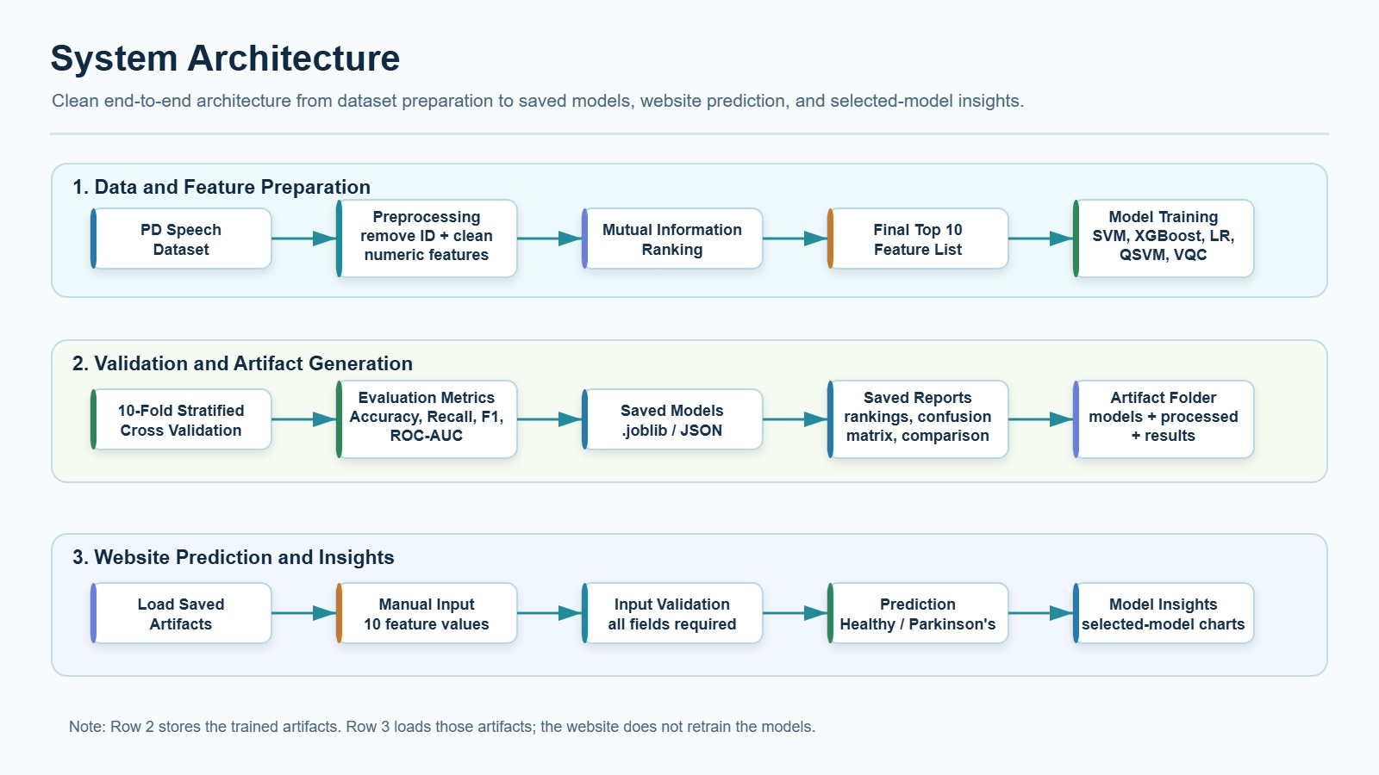

The suggested system architecture for detecting Parkinson's disease based on speech features is structured as a full-fledged solution, covering data preprocessing, feature extraction, model training, model evaluation, and deployment via web-based software interfaces. At first, the suggested architecture uses PD Speech Features dataset, which includes many extracted speech feature variables (more than 700 features). As part of the data preprocessing stage, non-numerical data handling, missing data filling by median values, and deletion of unnecessary variables are applied to achieve consistent datasets. Further, during feature selection, the Mutual Information ranking approach is used to select the most significant features, where only the top 10 features are retained.

The chosen features will be utilized to train several machine learning algorithms like Logistic Regression, Support Vector Machine (SVM), and XGBoost, as well as quantum machine learning models like Quantum Support Vector Machine (QSVM) and Variational Quantum Classifier (VQC). Cross-validation with 10 folds will be employed in order to validate the algorithmic models. The performances model will be evaluated based on measures such as accuracy, recall, F1, and AUC score. The trained models will be saved as artifacts in formats like .joblib and .json.
During the implementation stage, the system offers a web-based interface where users are required to manually enter the top 10 features’ values. After validation of the inputs, the system passes the values to the chosen trained model to generate predictions on whether the input values represent a healthy person or a Parkinson’s patient. The web application also shows insights about the models, including their performance, confusion matrices, and feature importance charts. Notably, the website only loads pre-trained models and does not train any models.

5.2 Data Flow Diagram

Data flow of the project can be separated into three stages. These are offline data preparation, model training and storing, and online predictions through website. In the offline phase, data preparation includes cleaning numeric columns, dealing with missing data through imputation, and transforming all features to be compatible with the pipeline. Selection of the best performing features takes place via Mutual Information Ranking, resulting in selecting a subset of features. In particular, the top 10 features are selected for model training.

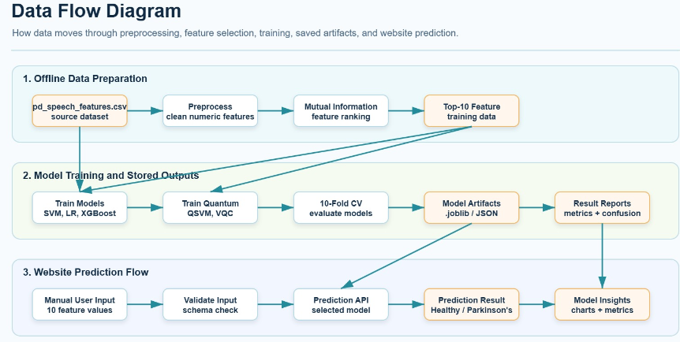

Model training stage consists of training classical and quantum models, as well as saving all trained models and other required data. All classic models such as Logistic Regression, SVM, and XGBoost are trained on datasets after applying standard data transformation pipelines. Quantum models such as QSVM and VQC also require dimensionality reduction, for example, applying Principal Components Analysis, and scaling of features to have a specific range. Cross-validation technique with 10 folds is used for evaluating each model. Results are recorded using several metrics. Moreover, all trained models with configurations used for training and data transformations are stored as artifacts for future reuse.

The workflow for predicting results in the website begins with the entry of values for the selected attributes by the user. The values will then be validated and then submitted to the prediction API service. After fetching the pre-trained model artifact from storage, the API runs the predictions without having to train again. This is followed by the generation of the output of the prediction results either “Healthy” or “Parkinson’s.”

5.3 Use Case Diagram

A use case diagram is an illustration of the interactions between the user and PD Speech Model Lab software. The main actors in the system are represented by the user who communicates with the application through various functions. In particular, the first stage involves the user providing input consisting of the top 10 feature values which reflect the main attributes of the speech dataset. When the user inputs information into the software, the next step consists of validating the entered data by checking whether all the necessary fields have been fulfilled.

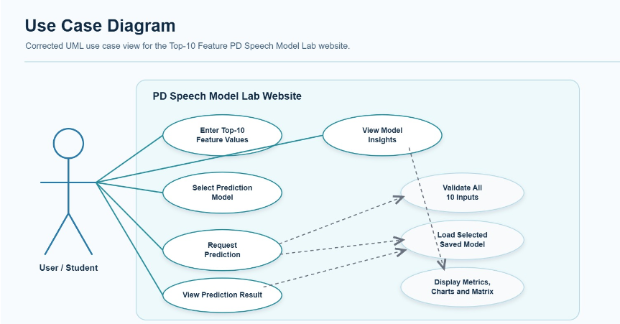

Next, the user may select one of the existing trained models or let the software use the default setting for the prediction. Upon completion, a prediction message will be sent to the user notifying about whether he/she belongs to the category of healthy or Parkinson’s patients. In addition to the prediction, it is possible to explore the results related to the chosen model such as performance graphs and model comparison. Moreover, the user can view model insights by exploring such evaluation methods as confusion matrices and feature importance.
Finally, it is possible to compare various trained models depending on their metrics, accuracy, recall, and F1 score.

CHAPTER 6

IMPLEMENTATION

The execution stage is where the recommended methodology will be implemented. This is done by integrating the data set, preprocessing techniques, machine learning algorithms, quantum algorithms, and prediction interface as one entity that facilitates inputs and outputs.

The main aim of this stage is to build a reliable pipeline that can take speech-based biomedical features, prepare them correctly, apply the trained models, and return predictions with probability scores. The implementation also includes explainability support, allowing the system to show which features influence the prediction.

6.1 Tools and Technologies Used

The algorithm is developed using the Python language due to its powerful capabilities in processing the data, machine learning, and quantum computing libraries. The data set is processed using libraries such as NumPy and Pandas.

Scikit-learn is used for preprocessing, feature scaling, PCA, model training, and performance evaluation. Machine learning models such as Logistic Regression along with Support Vector Machine are implemented using this library. XGBoost is used for gradient boosting based classification.

For quantum machine learning, Qiskit is used to create quantum feature maps, ansatz circuits, QSVM, and Variational Quantum Classifier models. The system also uses visualization and evaluation tools to compare model performance through metrics such as Accuracy, Recall, F1-Score, and AUC-ROC.

6.2 Hardware Components
Since the software component is dominant in the project, there is no need for any specialized hardware infrastructure for its basic operation. The system can be deployed on any computer/laptop with sufficient RAM along with computing capabilities to process the dataset.
For classical machine learning algorithms, it is enough to use a regular computer system. Quantum machine learning algorithms can be simulated, which means that one does not require a quantum computer to implement them. However, the effectiveness of quantum machine learning algorithms depends on the computing power of the system used.

6.2.1 Input Module
The purpose of this input module is to import the Parkinson’s speech dataset. The dataset consists of numerical voice parameters that will be classified. After the dataset is imported, the module will verify the correctness of the format and make it ready for processing.
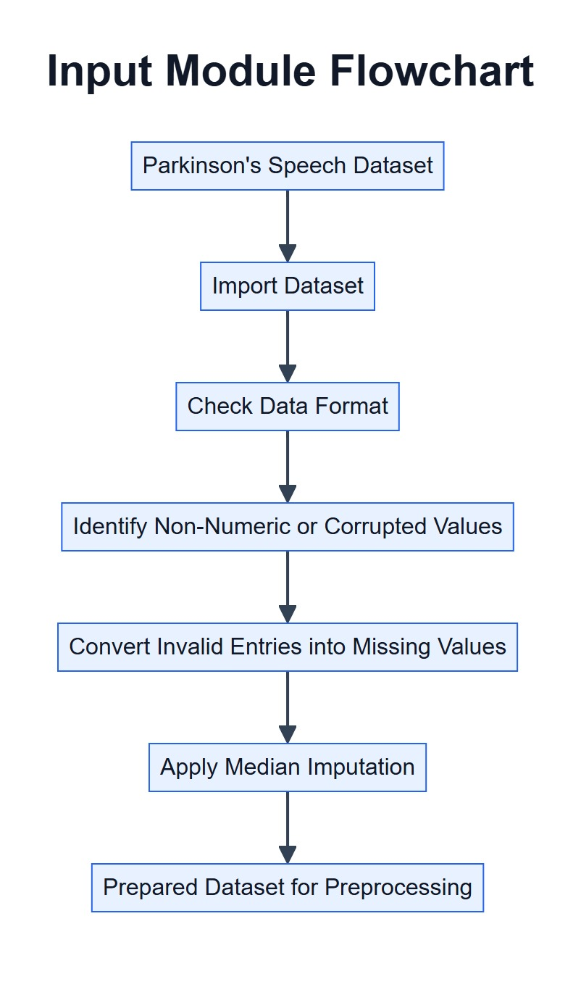

The module will also preprocess non-numerical data or data corruption by replacing them with missing values. The missing values will then be handled during the preprocessing step through median imputation. In essence, the input module will ensure that the remaining steps of the system will not encounter any issues related to data formatting.

6.2.2 Prediction

The prediction module uses the trained models to classify whether a given speech record indicates Parkinson’s disease or not. After the input features are preprocessed and scaled, they are passed to the selected classical and quantum models.

Each model produces a prediction, and where supported, a probability score is also generated. This probability score gives an estimate of how strongly the model associates the input record with Parkinson’s disease. The final output is intended to support medical review, not replace clinical diagnosis.

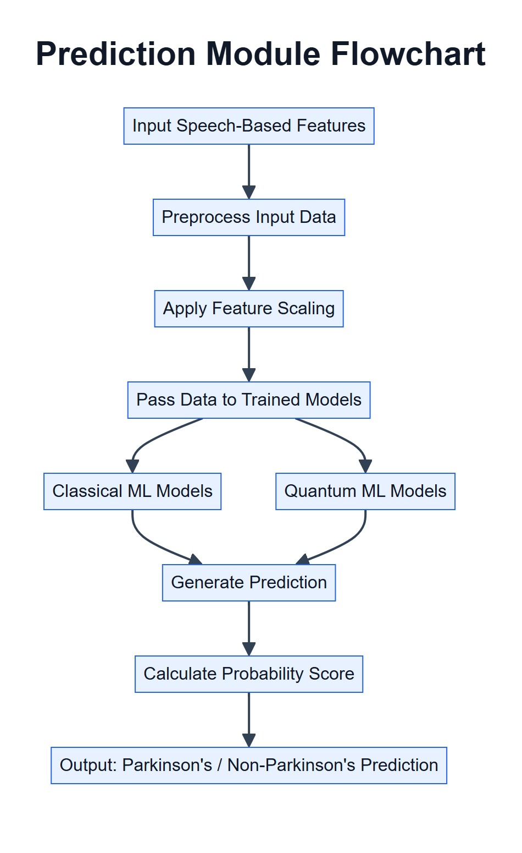

6.3 Code Logic Explanation

This code involves steps that follow each other. The first step includes loading and inspecting the data in order to detect any missing, non-numerical or inconsistent values. During the preprocessing step, the data will be converted into numerical form, imputed by median and split into training and testing sets.

Next, the features are scaled using standardization. For classical models, the scaled features are used directly for training Logistic Regression, SVM, and XGBoost models. Each model is evaluated using cross-validation and tested using performance metrics such as Accuracy, Recall, F1-Score, and AUC-ROC.

For the quantum models, PCA is applied before training to get reduce the number of input features. The reduced features are rescaled into a range suitable for quantum encoding. These values are then passed into quantum feature maps and ansatz circuits for QSVM and VQC implementation.
Once all models have been built and analyzed, the system evaluates their performance and picks the one that has performed best from among the classical models. The result of the prediction process consists of the class prediction and the associated probability score. The Explainable AI approach is then used to demonstrate what factors led to this conclusion.

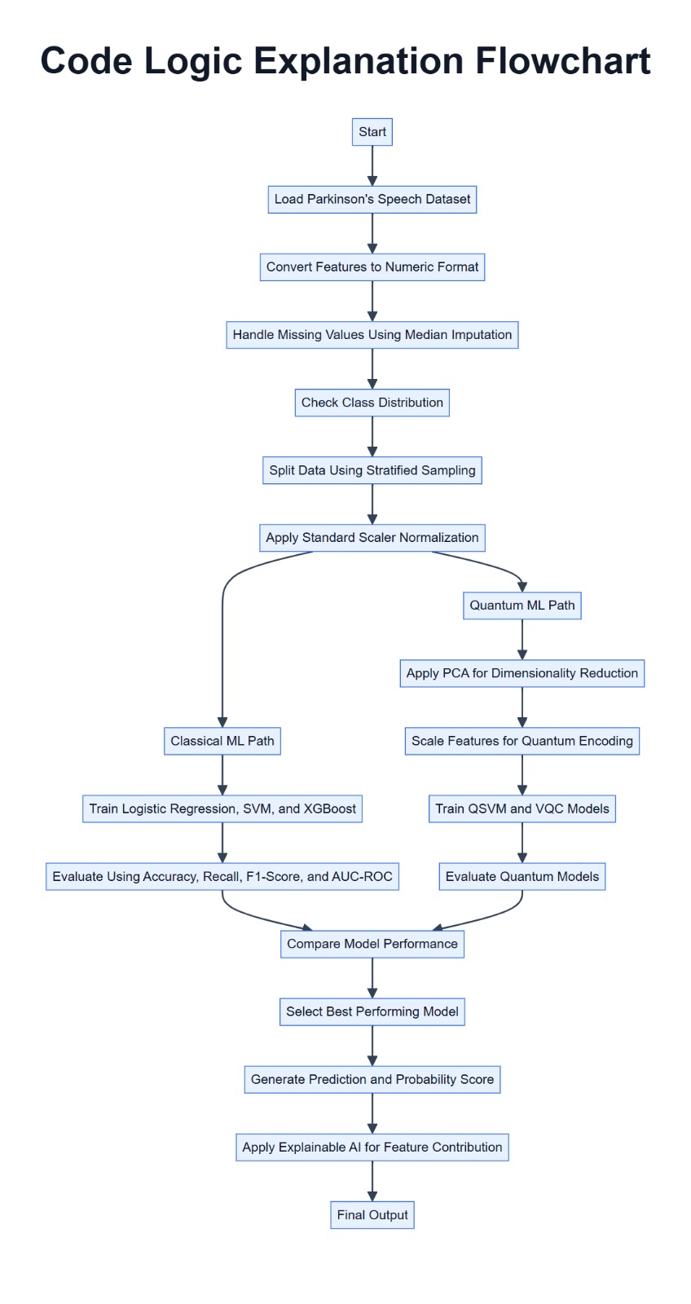
CHAPTER 7

RESULTS AND ANALYSIS

7.1 SYSTEM OUTPUTS AND SCREENSHOTS

The above output generated by the system represents the final stage of prediction within the Parkinson’s disease (PD) recognition algorithm. This involves the use of the trained classifier to classify the speech feature extraction results. Based on the above output, the prediction model shows that the disease “Parkinson’s (PD)” has a chance of 95.9%. This implies that there is a high possibility that the observed data points are classified under PD. Furthermore, the present state of the model is shown to be in the Inference-Ready mode, meaning that the model has been successfully deployed.
The prediction is produced through the pipeline of machine learning algorithms trained on the speech data set, wherein data preparation processes like handling missing values, normalization, and feature selection are done prior to training. According to the algorithm implementation, various models like Logistic Regression, Support Vector Machine (SVM), and Extreme Gradient Boosting (XGBoost) were assessed through cross-validation and testing parameters such as accuracy, recall, F1-score, and area under the curve (AUC).

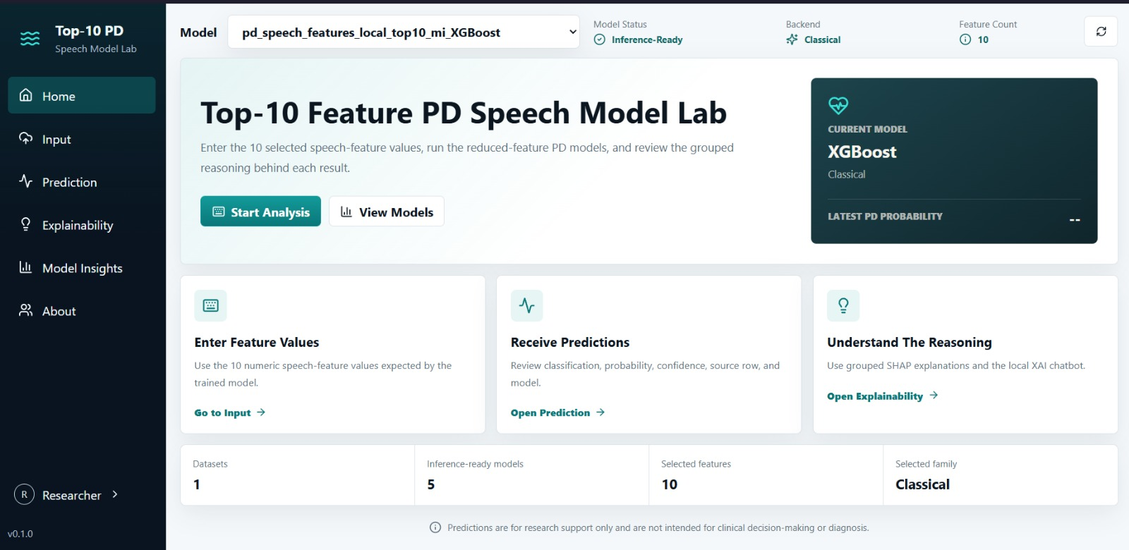

As shown above, this is the Top-10 Feature Parkinson’s Disease (PD) Speech Model Lab, which acts as the primary interface of the system. This interface has been created specifically to enable the analysis of PD speech indicators using only selected features from the available pool. Thus, rather than analyzing all available features, the system uses only the top 10 selected features, which form the basis for speech indicators of PD. The current model being used is indicated at the top, along with whether it can be used to run analyses and the model type (classical) used for predictions.

The interface enables the user to go through three basic stages of the process. The first stage requires the user to provide the necessary speech feature values. Then, after providing these values, the user can run the model to analyze probabilities and classifications, which can be further explained to see the rationale behind the system's predictions. Finally, there is an option to obtain additional details on the number of datasets, existing models, and selected features in the system.

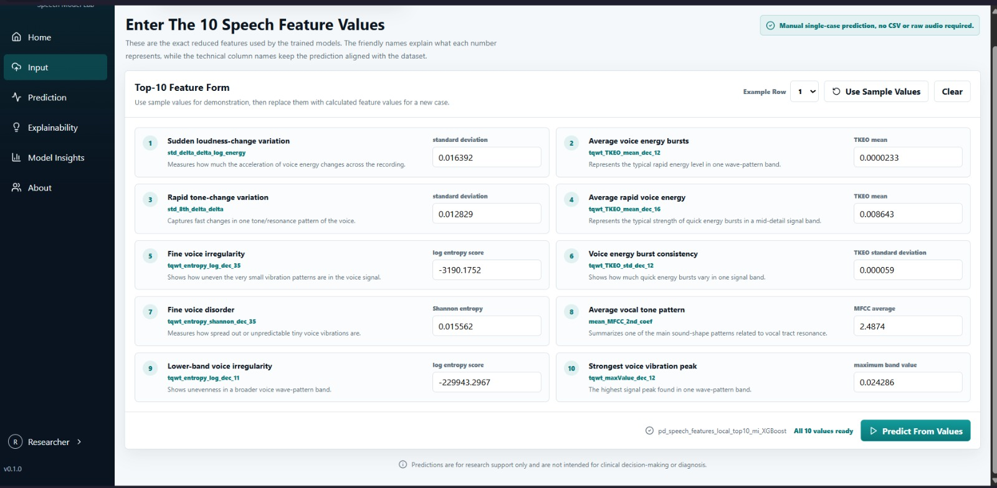

The provided interface is the input module of the Parkinson's Disease speech analysis system, in which the user manually enters the top 10 speech feature values to be used for prediction. In general, the feature values can be associated with specific features of the voice signal, such as energy and pitch changes, variability, and other parameters. To make the usage of this system clear, there are two kinds of feature representation: a scientific name and a description, helping users understand the features in layman's terms.
The input form itself is created to be easy-to-use; thus, it allows users to input their own values of speech feature characteristics or predefined values to demonstrate how the prediction process works. After the user has entered all necessary values, the system displays an appropriate message and activates the "Predict From Values" button, which passes the obtained information to the trained XGBoost classifier.

Among them, XGBoost exhibited better results with high recall and AUC. Thus, it can be considered an effective model for screening purposes where accurate positive detection is important. That is why XGBoost was selected as the deployed model for the application's interface.

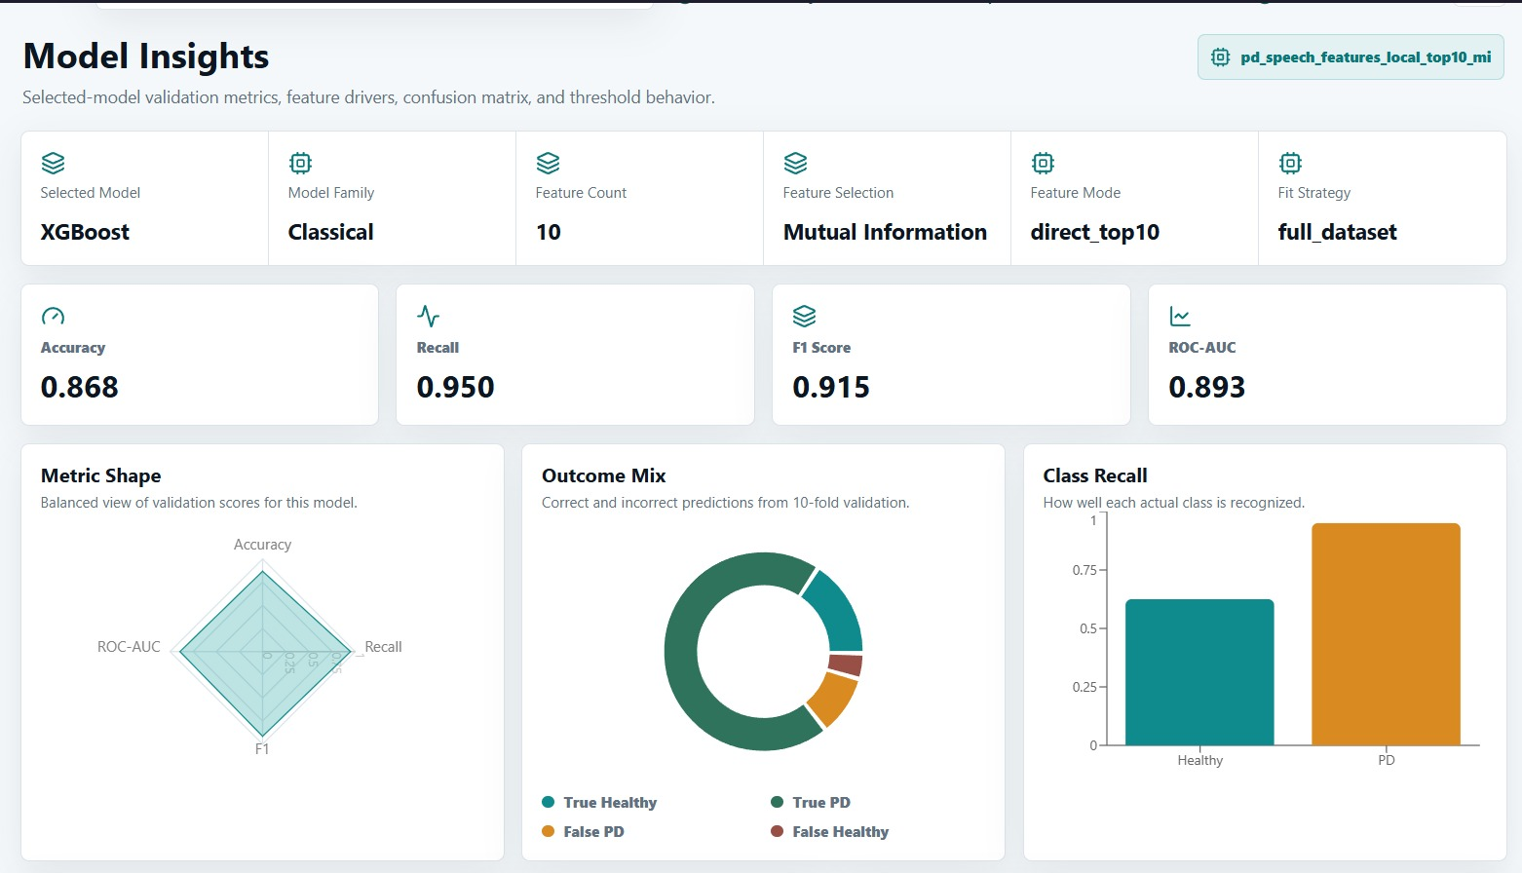

Model Insights section contains a thorough analysis of the selected XGBoost model, providing users with insights into the model's characteristics and performance. Key configuration options are highlighted, including the model type (classical), number of selected features (10), and feature selection based on the mutual information metric. The results obtained from the assessment are impressive, and include the following: accuracy of 0.868, recall of 0.950, F1-score of 0.915, and ROC-AUC of 0.893. High values of these metrics prove that the selected model performs well, especially in predicting Parkinson's disease cases, considering high recall.

Moreover, along with the numerical metrics, users can get the opportunity to interpret the performance metrics through several visualizations. Thus, metric shape visualization in the form of a radar chart demonstrates an even spread of values, which is a great sign of model performance. Outcome mix visualization presents the ratio of right and wrong predictions, showing that mostly the model predicts outcomes in accordance with reality. Class recall visualization represents the number of predicted and actual instances within each target class, confirming the higher ability of the model to predict the presence of Parkinson's disease, which is desirable for medical applications.
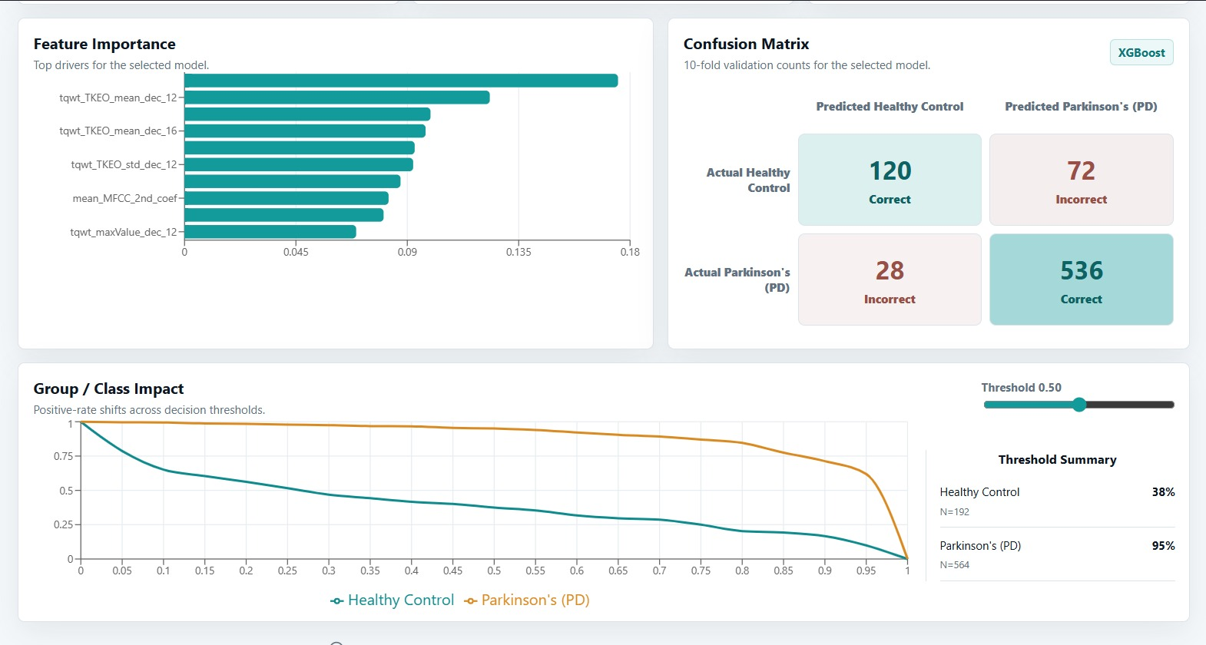

This section describes a more in-depth analysis of the predictive model based on feature importance and classification evaluation results. First of all, the feature importance chart helps identify the most significant speech characteristics that have been used for prediction by the XGBoost model. Specifically, such features as voice energy dynamics characteristics, including TKEO-based metrics, as well as frequency-dependent features are among those that were most valuable for the model's prediction. Thus, it can be concluded that voice energy changes and fluctuations of the analyzed signals help in detecting Parkinson's disease most accurately.

Secondly, the confusion matrix provides insight into the performance of the XGBoost model. Based on the results of this analysis, it can be said that 536 cases of Parkinson's and 120 healthy cases were detected by the model, whereas the amount of mistakes was low – there were only 28 false negatives and 72 false positives. Finally, group/class impact allows evaluating how prediction probabilities may change at various decision thresholds. Thus, at the standard threshold of 0.50, the detection rate is equal to 95% for Parkinson's and 38% for healthy classes.

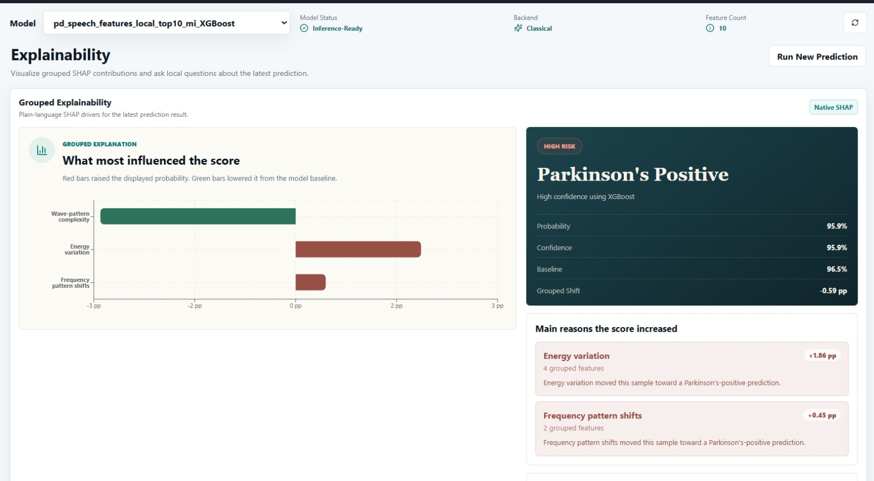

The explainability section presents further understanding of the reasons behind the prediction of the model. Using SHAP (SHapley Additive Explanations), the system determines the influence of each feature category on the prediction result. As illustrated in the figure, energy variation and frequency patterns had positive contributions to predicting Parkinson’s disease by increasing the probability score. Conversely, wave patterns had a slight negative contribution to the probability score but insufficient enough to change the outcome of the model's prediction.

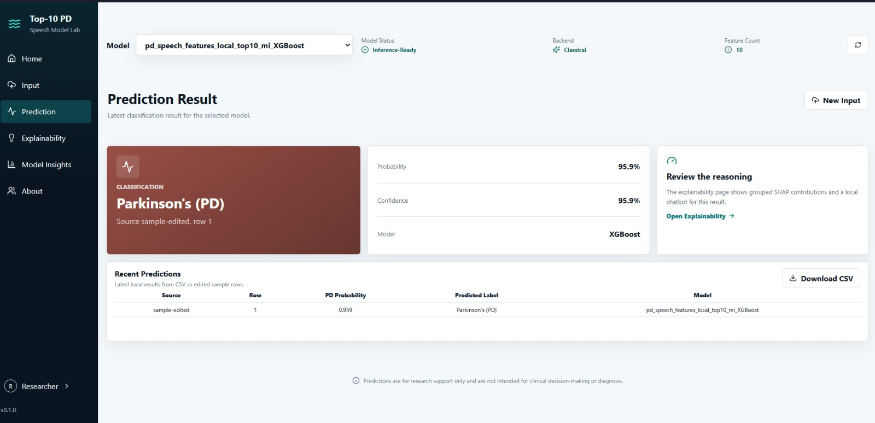

In summary, this model provides not only a reliable classification result of Parkinson's disease using voice data but also offers some explainable results. This kind of model is especially useful in practical medicine as it helps detect diseases at an early stage and provides assistance to medical professionals with both prediction and reasoning. Nevertheless, it should be noted that the application of such models is possible only in the framework of research and decision making, and not for diagnosis alone.

7.2 PERFORMANCE ANALYSIS

Performance analysis for the proposed Parkinson's Disease detection system was done by evaluating different models' performance on the given speech dataset. The speech dataset contains 756 samples with a total number of 755 speech feature values. These features have undergone preprocessing methods like filling missing values and normalizing data. Stratified sampling was used when splitting the dataset into training and test datasets to make sure both datasets have balanced classes. Additionally, 10-fold cross-validation was performed for all the models.

The comparison involved three classical machine learning models including Logistic Regression, SVM, and XGBoost. These models were evaluated based on metrics like Accuracy, Recall, F1-Score, and AUC-ROC. XGBoost showed the best results among the three models mentioned earlier. It achieved a good accuracy score of approximately 87.5%. XGBoost showed a very impressive Recall score of around 97.3% which is vital especially in applications in the field of medicine as it means that there will be few cases when the model failed to detect patients with Parkinson's Disease. Furthermore, this model got a pretty high F1-Score of roughly 0.92 and AUC-ROC of approximately 0.93.
Table 7.2 Performance Analysis of Classical Machine Learning Models
Model | Accuracy | Recall | F1-Score | AUC
Logistic Regression | 0.8553 | 0.9381 | 0.9060 | 0.8483
SVM | 0.8224 | 0.9646 | 0.8898 | 0.8745
XGBoost | 0.8750 | 0.9735 | 0.9205 | 0.9274

In addition, Logistic Regression and SVM yielded competitive results but proved less effective than XGBoost. In particular, the accuracy of Logistic Regression was slightly below 85.5%, with high recall and a good F1-Score, indicating high stability. The second model is SVM, which produced a relatively high recall (~96.4%) but at the cost of low accuracy (about 82.2%). However, due to a very high recall rate, the SVM model can be considered a reliable classifier for identifying positive instances, despite rather low precision. Therefore, all models work effectively, with XGBoost being the most accurate and sensitive.

In addition to classical approaches, quantum machine learning methods were also evaluated in this experiment. Specifically, models such as QSVM (Quantum Support Vector Machine) and VQC (Variational Quantum Classifier) achieved relatively low accuracy (74-75%) but very high recall rates (~97%). Even though both models' accuracy is not as high as that of their classical counterparts, their high recall makes them promising and potentially useful in the future.

Table 7.2 Performance Analysis of Hybrid Quantum Machine Learning Models
Model | Accuracy | Recall | F1-Score | AUC
QSVM | 0.7566 | 0.9735 | 0.8560 | 0.73
VQC / QNN | 0.7434 | 0.9735 | 0.8494 | 0.76

In summary, the result of the performance analysis demonstrates that the designed model is effective in diagnosing Parkinson's disease based on speech, with XGBoost proving to be the best model for the classification task. With high levels of recall, AUC-ROC score, and consistency in accuracy, it can thus be employed as a complementary diagnostic solution. It is crucial to note that in such cases as medical diagnostics, it is necessary to balance different performance measures to avoid potential risks.

CHAPTER 8

ADVANTAGES AND LIMITATIONS

The proposed system uses speech-based biomedical features to predict Parkinson’s disease through classical machine learning, quantum machine learning, and Explainable AI. One clear advantage of this approach is that speech data is non-invasive and easier to collect compared with many clinical tests. Since speech changes are commonly observed in Parkinson’s disease, voice-based analysis provides a useful direction for early screening and research-based decision support.

The application of classical algorithms like Logistic Regression, Support Vector Machine, and XGBoost provides a solid prediction foundation to the model. These algorithms are good at working on structured data and can be trained easily. Logistic Regression is an interpretable algorithm, Support Vector Machine excels in high dimensional data, and XGBoost captures non-linear relationships easily. Comparison between the algorithms helps in finding out which one works better for a particular data set.

The project also includes quantum machine learning models such as QSVM and VQC. These models allow the system to explore how quantum feature maps, ansatz circuits, and quantum-based classification can be applied to biomedical prediction. Since quantum machine learning is still developing, this part of the work is treated as experimental rather than as a replacement for classical models.

Another advantage is the use of Explainable AI. In healthcare-related systems, prediction alone is not enough. The model should also give some indication of why a particular result was produced. XAI helps identify the features that influence the prediction, making the output easier to review and interpret.

At the same time, the system has limitations. It depends heavily on the quality, size, and diversity of the dataset. If the dataset does not represent different populations, recording conditions, or disease stages, the model may not perform well on new data. The current implementation is also software-based and does not include real-time voice recording, hospital integration, or clinical testing.

The quantum algorithms are restricted because of the limitations of simulation and feature size. The PCA process reduces the number of features needed to be used for quantum computing, but on the other hand, it eliminates some of the data which was contained within the original data set. Hence, it would be wise to interpret the findings from the quantum algorithm experimentally. Lastly, it should be noted that the system is not to be used for diagnosis purposes alone.

8.1 Limitations of the System

However, the limitation to the model is that it is based on the Parkinson’s disease voice data set. The performance of the model will depend largely on the quantity and the features contained in the dataset used in developing the model. For instance, if the dataset is limited, the accuracy of the model will be low.

Another limitation is that the system does not process raw voice recordings directly. It works with already extracted speech features. Because of this, the system does not yet provide a complete end-to-end solution where a user records speech and receives an automatic prediction.
The quantum machine learning part also has practical limits. QSVM and VQC require a smaller number of input features, so PCA is used before quantum encoding. While this makes the quantum models easier to run, it may reduce some information from the original feature set. Since the models are tested using simulators, their performance on real quantum hardware remains uncertain.

The problem of generalizability of the model is also an issue here. Though the trained model does quite well with one data set, it might not perform equally well with another data set obtained by the use of various microphones, languages, age groups, or stages of diseases. Additional research needs to be done with large amounts of other data sets.

The Explainable AI feature increases clarity, yet it is not evidence of any medical cause-and-effect relationship. The feature importance scores indicate the variables that have played a role in building the model; however, they are not proof of clinical evidence that these variables cause Parkinson's disease.

CONCLUSION AND FUTURE WORK

The following project has built a model for predicting Parkinson's disease by utilizing various features related to speech analysis, classical machine learning, quantum machine learning, and XAI. The data set was pre-processed using numeric encoding, removal of missing values, stratified sampling, and feature scaling. Various classical models like Logistic Regression, Support Vector Machine, and XGBoost have been used to train our models using accuracy and F1-score.

The results show that speech features can provide useful information for distinguishing between Parkinson’s and non-Parkinson’s cases. Classical machine learning models remain practical and reliable for this type of structured dataset. The quantum machine learning models, including QSVM and VQC, add an experimental comparison and help study how quantum-based methods behave on reduced speech features. However, the current quantum results should be interpreted carefully because they depend on PCA, circuit design, simulation limits, and the available execution environment.

The explainability feature of the model is yet another crucial aspect that the system gains from using explainable AI. In addition to understanding of the factors that contribute to the model's decisions, it increases the readability of the predictions. This feature is extremely significant when it comes to medical application domains since users require more than just a classification.

There are many ways that can improve the system to help future research in refining the system. Firstly, it would be helpful to conduct an experiment using speech samples collected from different populations under different circumstances and at different phases of the disease.

The system can also be extended by adding real-time voice input and automatic feature extraction from recorded speech. A simple user interface could allow users to upload or record speech samples and view prediction results with probability scores and explanation summaries.
In terms of the quantum aspect, future research directions could consist of exploring novel methods for encoding features, optimizing ansatz circuits, utilizing hybrid optimization methods, and conducting experiments on real quantum computers as soon as they become available. In the case of Explainable AI, one of the possible future advancements could be to test different explanation methods and validate their accuracy with domain experts.

In summary, this paper illustrates that combining machine learning, quantum computing, and explainability results in the development of a feasible research-driven model for forecasting Parkinson's disease. Although this algorithm does not replace clinical analysis, it may be used in future studies and act as an aid to doctors when verified appropriately.

APPENDICES

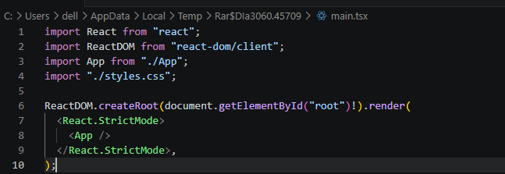

APP.PY

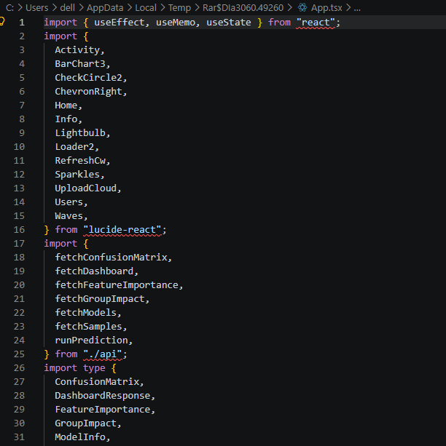

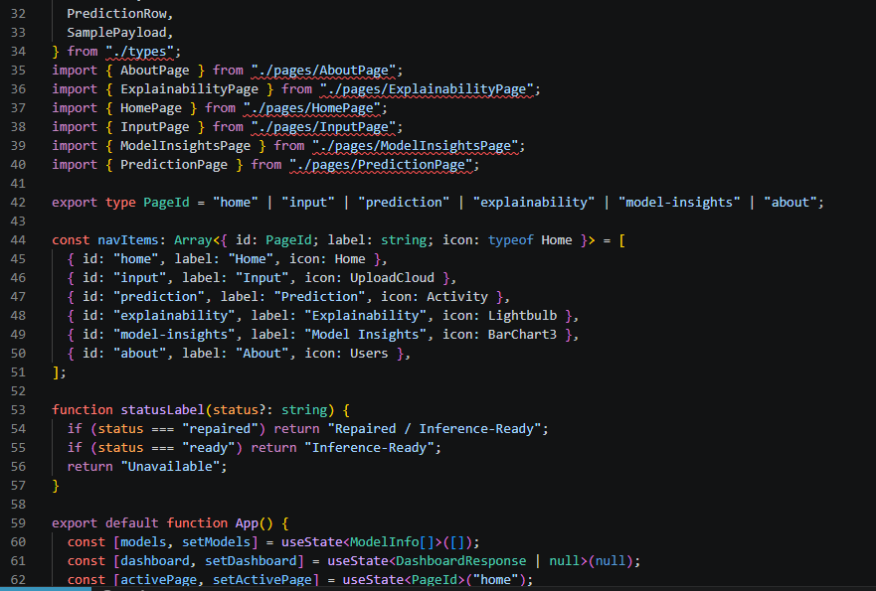

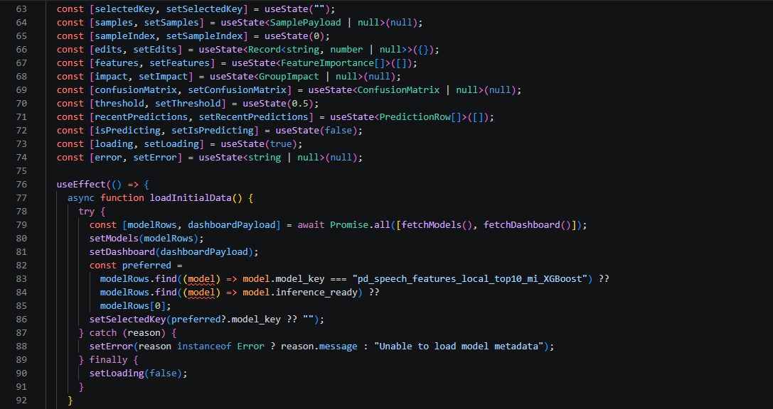

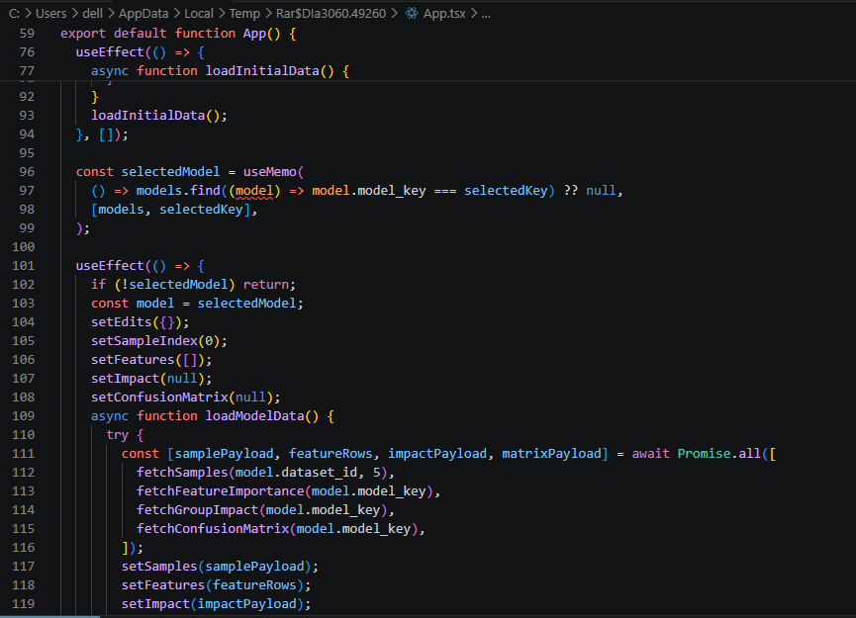

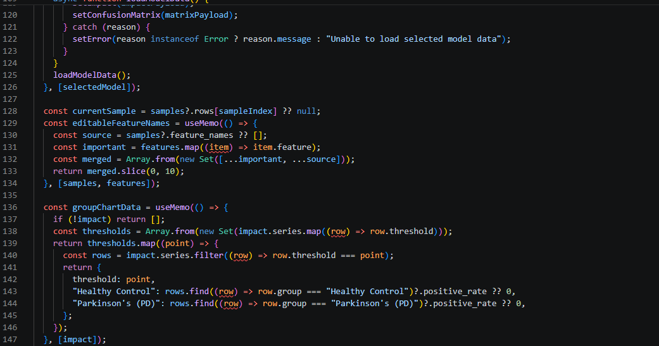

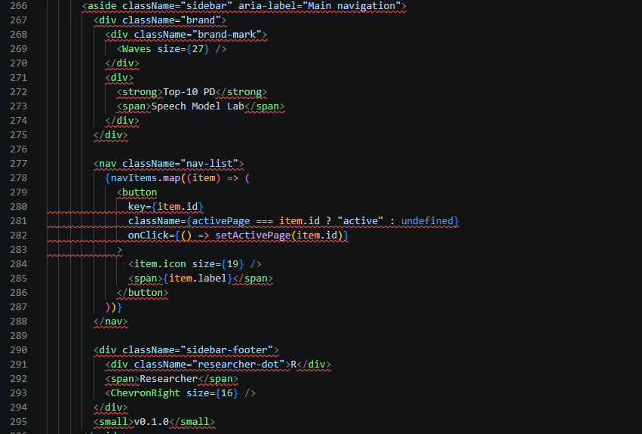

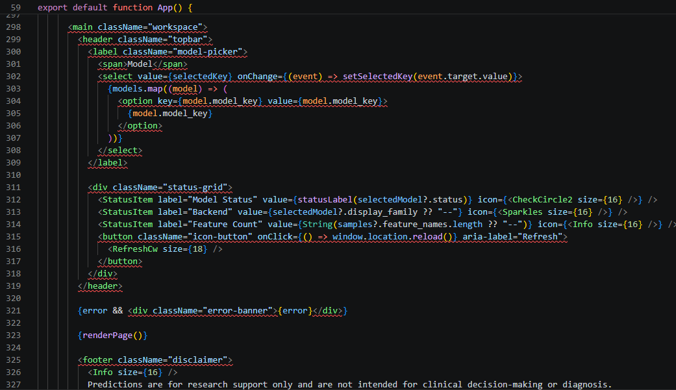
MAIN.PY

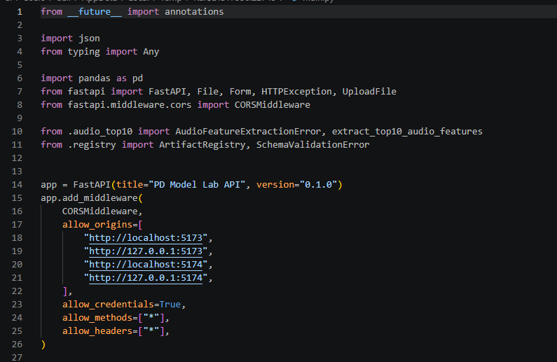

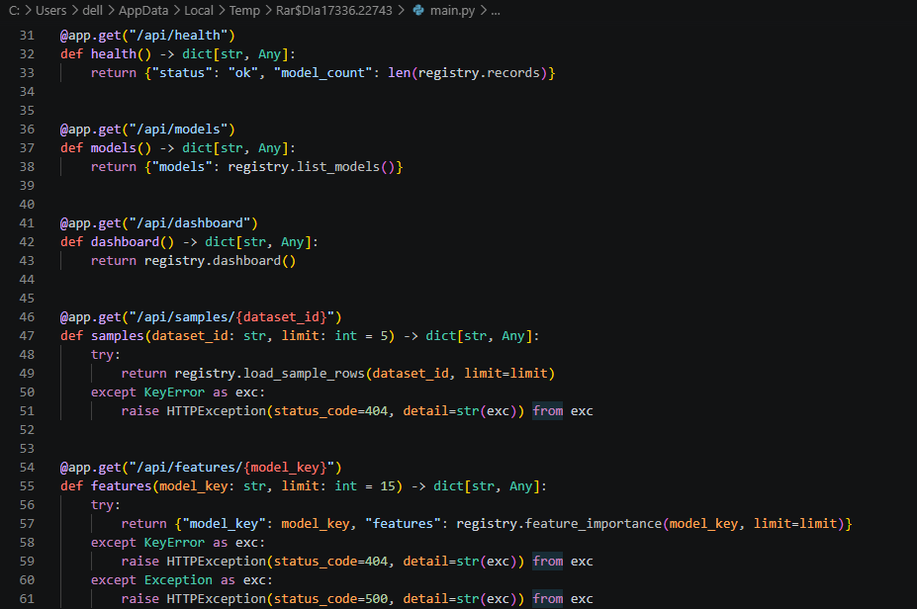
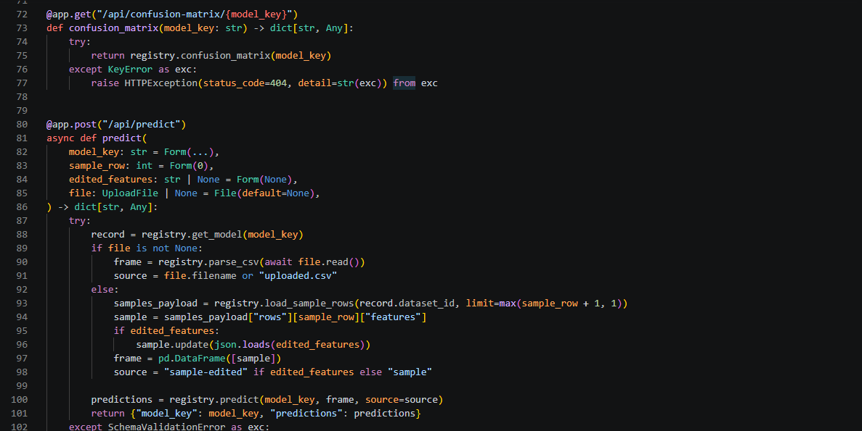

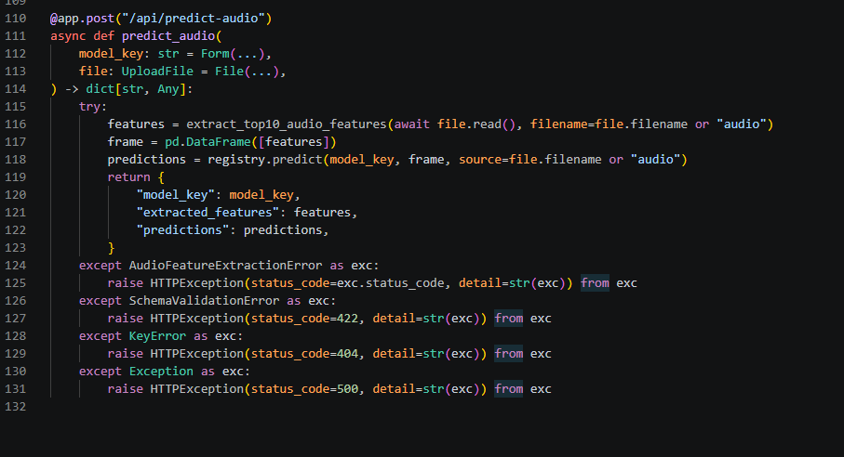

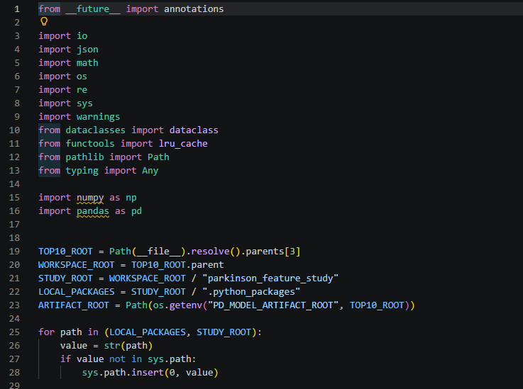

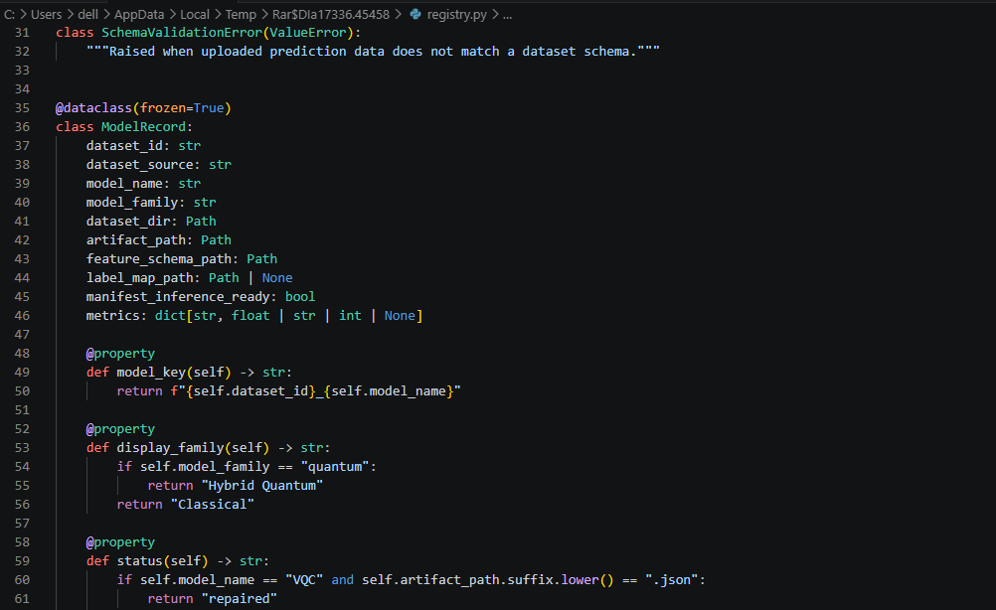

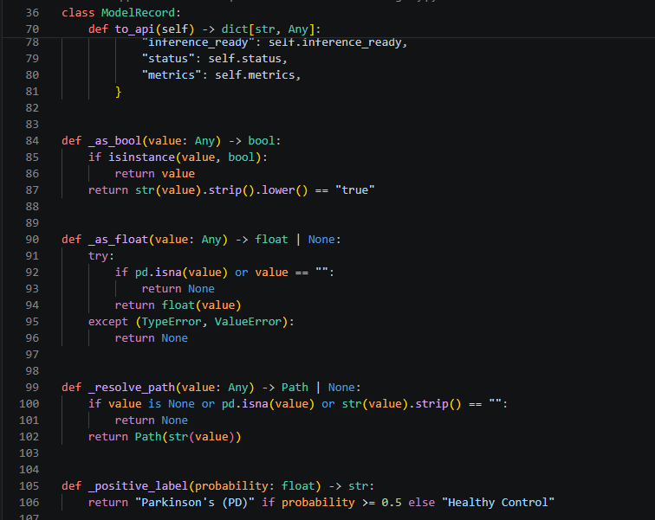

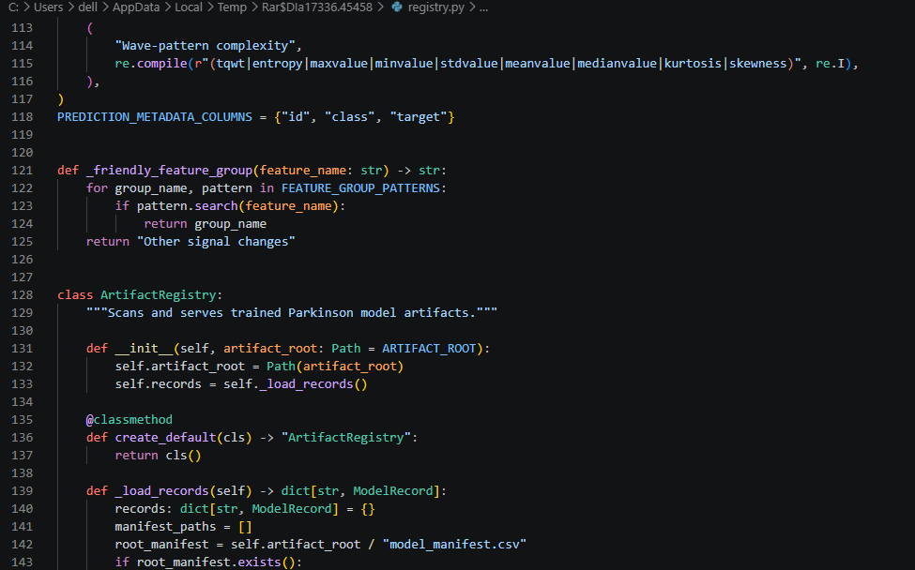




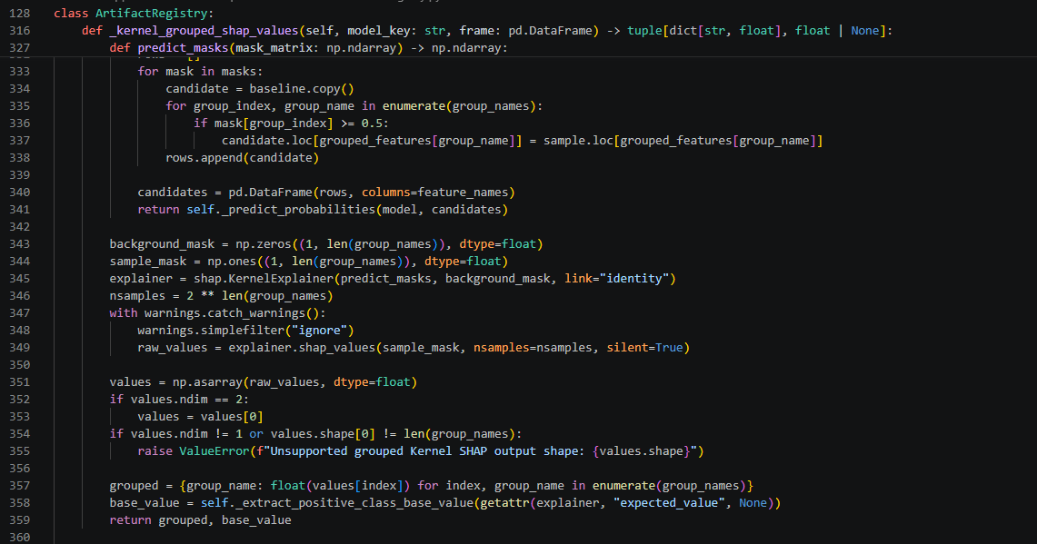

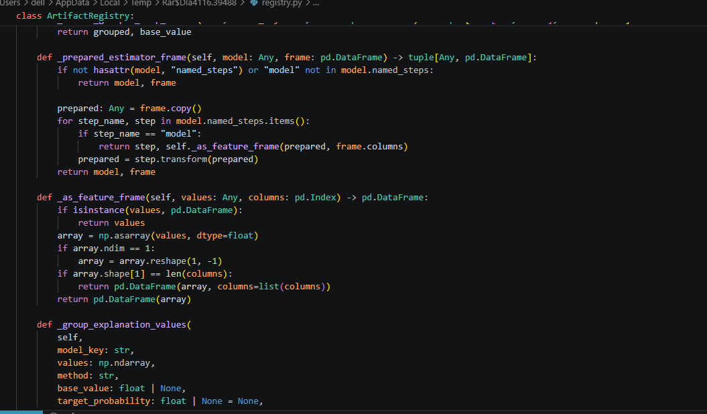

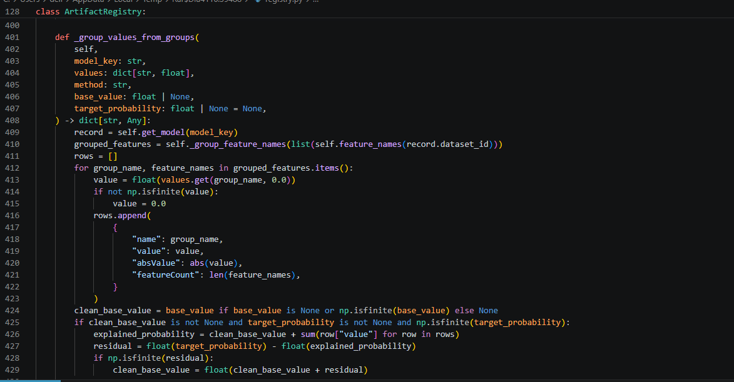

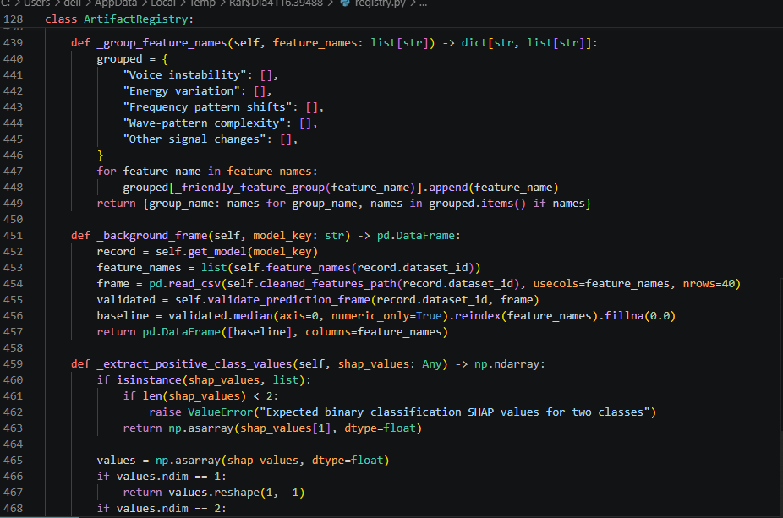

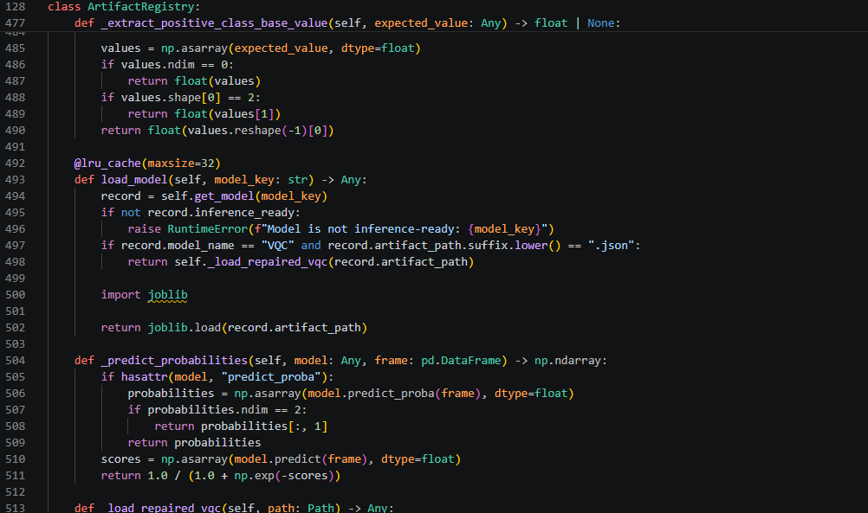

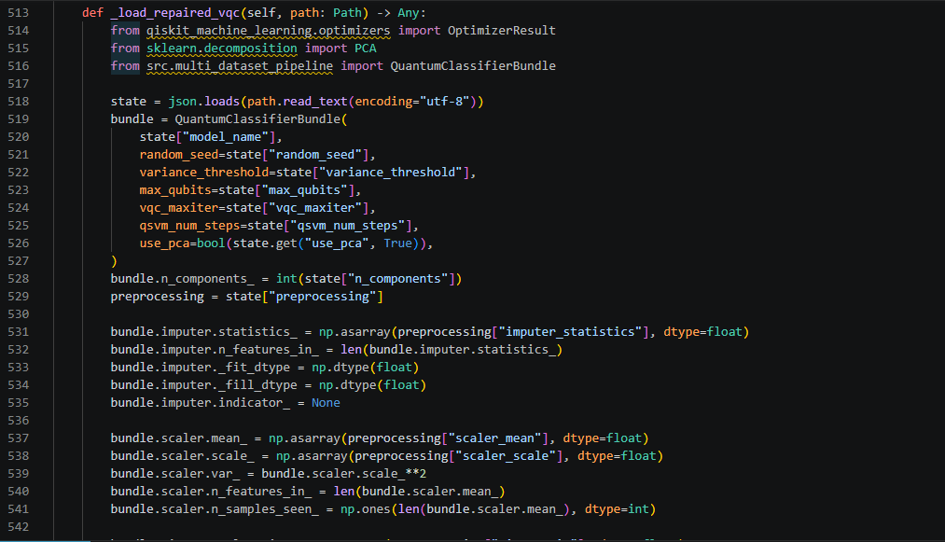

REFERENCES

- S. P. Siddique Ibrahim, A. Das, N. Gaurav, L. P. Mishra, and P. Kanyal, “Healthcare analytics: Data mining techniques on electronic health records (EHR) to build a predictive model for early disease diag- nosis,” in Proc. 2025 Int. Conf. Sustainable Communication Networks and Application (ICSCN), 2025, pp. 1618–1625. DOI: 10.1109/IC- SCN67106.2025.11308699.

- S. P. Siddique Ibrahim, K. B. S., V. S. B., J. Naru, and N.
L. T., “Predicting kidney damage in hypertensive patients using machine learning,” in Proc. 2025 Int. Conf. Engineering Inno- vations and Technologies (ICoEIT), 2025, pp. 1199–1204. DOI: 10.1109/ICoEIT63558.2025.11211665.

- J. C. Vasquez-Correa, T. Arias-Vergara, and J. R. Orozco-Arroyave, “Speech biomarkers of Parkinson’s disease: Advances and open chal- lenges,” Biomedical Signal Processing and Control, vol. 92, p. 105120, 2024. DOI: 10.1016/j.bspc.2023.105120.

- A. Tsanas, M. A. Little, and L. O. Ramig, “Remote speech anal- ysis for monitoring Parkinson’s disease progression,” IEEE Re- views in Biomedical Engineering, vol. 17, pp. 98–111, 2024. DOI: 10.1109/RBME.2024.3369012.

- Y. Xu, J. Wang, H. Li, and Z. Chen, “Speech-based biomarkers for early Parkinson’s disease detection: Advances in acoustic anal- ysis and machine learning,” IEEE Transactions on Neural Systems and Rehabilitation Engineering, vol. 33, pp. 112–126, 2025. DOI: 10.1109/TNSRE.2025.3459123.

- M. Sedigh Malekroodi, T. Bocklet, and B. Schuller, “Transformer- based speech representation learning for Parkinson’s disease detec- tion,” Computer Speech & Language, vol. 84, p. 101595, 2025. DOI: 10.1016/j.csl.2024.101595.

- Y. Ji, L. Zhang, and J. R. Orozco-Arroyave, “Subtype-aware Parkinson’s disease speech analysis using graph-based machine learning,” Pattern Recognition, vol. 148, p. 110072, 2025. DOI: 10.1016/j.patcog.2024.110072.

- S. Valarmathi, R. Kumar, and G. Prasad, “Linking acoustic speech features to striatal dopamine depletion in Parkinson’s dis- ease,” Frontiers in Neuroscience, vol. 19, p. 1298347, 2025. DOI: 10.3389/fnins.2025.1298347.

- C. Simone, F. Hirsch, and E. No¨th, “Explainable artificial intelligence for speech-based neurological disorder assessment,” IEEE Journal of Biomedical and Health Informatics, vol. 29, no. 3, pp. 1032–1043, 2025. DOI: 10.1109/JBHI.2025.3447812.

- J. M. Chow, “Quantum machine learning for clinical decision support systems: Opportunities and limitations,” Nature Digital Medicine, vol. 8, p. 42, 2025. DOI: 10.1038/s41746-025-01042-9.

- M. Rahman and J. Zhuang, “Noise-aware quantum neural networks for biomedical signal classification,” IEEE Access, vol. 13, pp. 45712–45725, 2025. DOI: 10.1109/ACCESS.2025.3559214.

- A. Demidik, M. Schuld, and N. Wiebe, “Quantum kernel methods for biomedical data under realistic constraints,” Quantum Machine Intelligence, vol. 7, no. 1, p. 9, 2025. DOI: 10.1007/s42484-025-00109-6.

- A. Pandey and S. Mandal, “Hybrid quantum–classical learning frame- works for healthcare data analytics,” Quantum Information Processing, vol. 24, no. 3, p. 87, 2025. DOI: 10.1007/s11128-025-04087-2.

[14] V. R. Patheda, G. Laxmisai, G. Bv, S. P. Siddique Ibrahim, and S. Selva Kumar, “A robust hybrid CNN+ViT framework for breast cancer classification using mammogram images,” IEEE Access, 2025. DOI: 10.1109/ACCESS.2025.3563218.

[15] S. K. Reehana and S. P. Siddique Ibrahim, “Multi-class spectral–spatial temporal pyramid network and multi-class classifier-based cardiovascu- lar disease classification,” Frontiers in Physiology, vol. 16, 2025. DOI: 10.3389/fphys.2025.1650134.

